Inclusive Worship: Creating a Language and Multisensory Options Where All can Participate
  - Presenter: Barbara Newman

How I started this work
Psalm 139:13
Most important place to Begin –Getting to know the individual
Green and Pink

Asking the right question- What can the individual do?
- How does the individual take in information?
- How does the individual get information out
- What movements can the person do?
- Does the individual have sensitivities to sensations?
- What equipment or supports might be needed for this individual?

The Vertical Habits Story
“God’s language school” – Quote from Thomas Long

- Love You (Praise) –Psalm 47:6-7
Idea bank for “Love You”:
- Wrist Ribbons
- Flags
- Shaky Eggs
- Break Tickets

- I’m Sorry (Confession)—Psalm 51
Idea bank for “I’m Sorry”:
- Sorry
- I forgive you
- Expectations for behavior
3. I’m Listening –Psalm 119:9-11, 15-16
Idea bank for “I’m Listening”:
- Mutli-Sensory
- BIG IDEA
- Adapted Curriculum, Friendship Ministries Curriculum
- Story Stick, Story Apron
- Speech Buttons
- YouVersion and YouVersion Kids

Vertical Habits in horizontal community (example: Lighthouse Christian Ministries)

Some materials to help you:

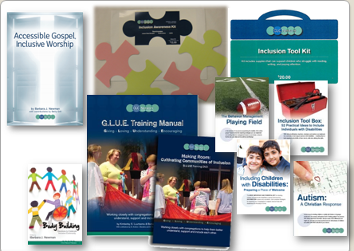
Vertical Habits showcase
- http://worship.calvin.edu/resources/resource-library/showcase-vertical-habits-worship-and-our-faith-vocabulary/
- http://psalmsforallseasons.org/vertical-habits

Connect with CLC Network for further resources:
www.clcnetwork.org/blog

