Presenter: Barbara J. Newman

Sunday School Where Everyone Is Welcome: Universal Design for

Religious Education

What DOES your congregation DO?

Lesson from the Boy Scouts: Always Be Prepared!
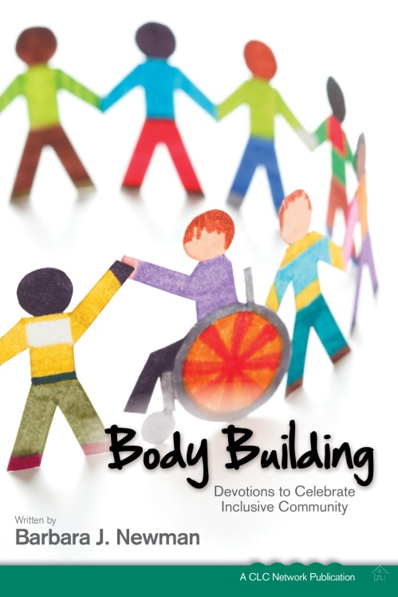
Prep Work
- Congregational Attitudes
  - True/False Quiz
  - Tools: CLC’s Free DVD &
- Accessibility
  - www.CRCNA.org
- Give Information:
  - Church Welcome Story & Adaptations: Youth Group Event Story, Communion Story, How do you worship? What do you wear? How many questions are appropriate?
- Your congregation’s website or printed materials
  - Tour of children’s area, people engaged in worship, what do you wear, printed welcome for children with disabilities, etc.
- Training for Leaders and Peers
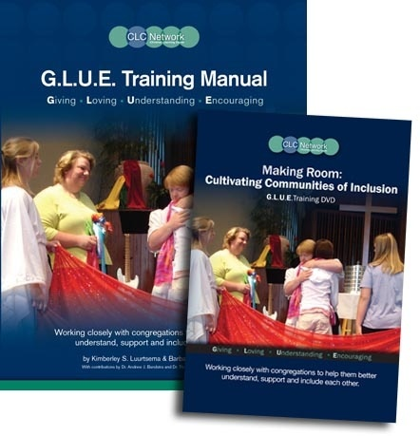
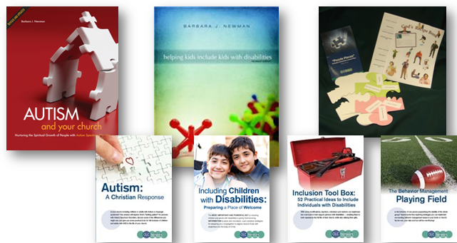
- Intake System
  - Registration: WORDING is critical!
- Special Needs Coordinator
- Awareness of G.L.U.E. process (because, ASAP)
- You MUST get to know the CHILD
  - So you can make a specific plan
- Be prepared to have conversations with parents
- Have a local resources list

Meet and Greet
- Parking Passes
- Data Collection –intake system signals a process
- Instant Buddies (have them available!)
- For that tough customer…it’s OK to ask parents to wait until you get some things in place (1-2 weeks)
In-Room Supports
- Pictures, pictures, pictures!
  - Visual Schedules
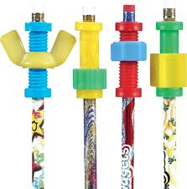
  - Story apron, Story stick
  - Speech buttons
  - Curriculum
- Items to address unique sensory systems
  - Hand tools (fidgets), Fidget pencils
  - Varied seating
  - Lap buddies
  - Wiggle cushions
  - Parking Spots
- Fine Motor Tools
  - Varied pencils & grips
  - Paper options
  - Scissors options
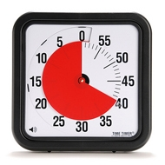
- Stations, multisensory, Choices! Choices! Choices!
- Invaluable Items
  - Time Timer
  - Break Tickets and Break Area
  - Concrete items & bins to go with stories and lessons
  - YouVersion (kids)
What WILL your congregation DO?

Why? Adam’s story

