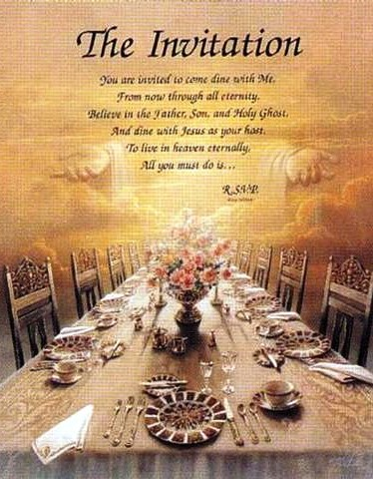

The Messianic Banquet: Isaiah 25:6-9 &
Luke 14 Connection
Insights from Kenneth Bailey &
Gary Burge

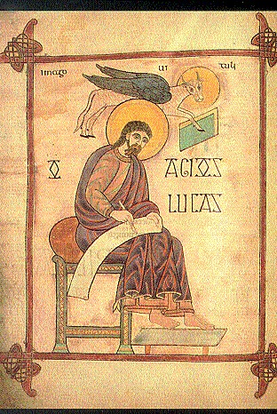

The Gospel of
Luke

Outline of Luke

- I. Introduction to Jesus’ Ministry (1:1-4:13)
- II. Ministry In and Around Galilee (4:14-9:50)
- III. Jesus’ Teaching On the Way to Jerusalem (9:51-18:34)
- IV. Jesus in Judea: Ministry Near and in Jerusalem (18:35-21:38)
- V. The Climax of Jesus’ Life (22:1-24:53)

In the Shadow of the Cross
Teachings of Jesus in Luke’s Central Section (9:51-18:34)

Chiastic Structure of Luke’s Central Section (9:51-18:34)

- Opposition & the Cost of Discipleship (9:51-62)
- Mission of the Seventy (10:1-24)
- Love of Neighbor, Love of God (10:25-42)
- Teaching on Prayer (11:1-13)
- Leaders Resist Christ’s Message (11:14-54)
- Judgment to Come (12:1-13:9)
G. Kingdom Reversals (13:10-14:24)
F’ Cost of Discipleship (14:25-35)
E’ Seeking and Saving the Lost (15:1-32) D’ Use and Abuse of Riches (16:1-31)
C’ Teaching on Faith, Loving Neighbor & God (17:1-19) B’ The Coming of the Kingdom (17:20-18:8)
A’ The Requirements for Entering the Kingdom (18:9-34)

Kingdom Reversals (13:10-14:24)
A Closer Look

13:10-35 14:1-24

- Healing a Disabled Woman on the Sabbath.
- Parables of the Mustard Seed
and Yeast: the kingdom of
God’s humble and seemingly insignificant beginnings.
- The Narrow Door: the humble will walk through it.
- Sorrow for Jerusalem: the unwillingness of the prideful to accept Christ’s message leaves
her desolate (eschatological focus).
- Healing a Man With Dropsy on the Sabbath
- Parable concerning Seat Selection:
Take the humble and seemingly insignificant seat
- Parable of the Banquet: invite the
humble: the poor, the crippled, the lame, the blind
- Parable of the Great Banquet: the unwillingness of the prideful to accept the invitation leaves them out; but the disabled will be accepted (eschatological focus).

Kingdom Reversals
(13:10-14:24)
Not What You Would Expect

- Who understood Jesus’ message? Those whom you would least expect:
- The poor, the crippled, the lame and the blind.

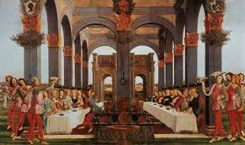

Back to the Messianic Banquet…

A READING OF LUKE 14

Setting the Scene:
The Parable of the Great Banquet in Luke 14

It is better, Jesus says, to invite the needy.
Someone remarks, “Blessed is he who shall eat bread in the Kingdom of God.”

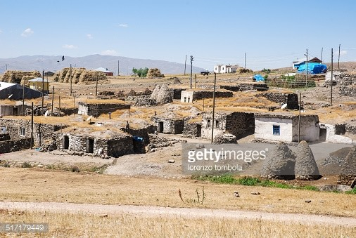
Setting the Scene:
The Parable of the Great Banquet in Luke 14

Setting the Scene:
The Parable of the Great Banquet in Luke 14

The person’s remark about the Kingdom of
God is a challenge for Jesus’ views on the topic.

The Three
Excuses

What An Invitation Meant in
in the Middle Eastern Context

Typically In the West, we interpret
ourselves as the banquet hosts and the world as potential guests.
Making it a parable about evangelism

Western Misunderstanding

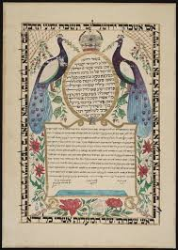

Invitation in Jesus’ Day

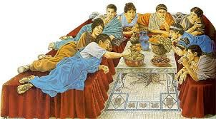
Invitation in Jesus’ Day

The Real Estate Excuse

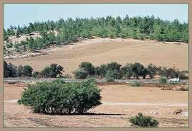
The Real Estate Excuse

The Real Estate Excuse

It is impossible that he would buy and
and “not have seen it.” This is an insult.
A man who originally agreed to attend
the banquet is now saying “No.” And his excuse is a shocking insult.
No honorable guest would ever act like this.

The Plowing Excuse

The Plowing Excuse

The Plowing Excuse

The idea here is that testing comes
before buying.
In our culture it would be the same as if one declined an invitation at the last
minute saying:
“I have just bought a used car by texting and I need to go see if it will start.”

The Plowing Excuse

There can be no circumstance in which an animal comes before the obligation to attend a prepared banquet.
This man who had once agreed to attend the banquet, who once said “yes” now says “no.”
No honorable guest would ever act like this.

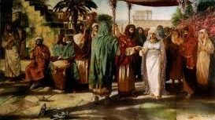

The Marriage Excuse

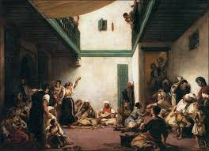
The Marriage Excuse

The Marriage Excuse

This man does not show the typical
culture restraint in personal sexual matters.
In a culture that barely refers to women
in literature, this man uses his wedding as an excuse.

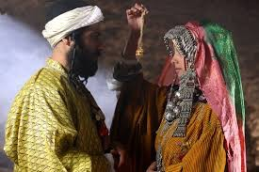

The Marriage Excuse

Back to the Story…

The servant came back and reported this to his master.
Then the owner of the house became angry and ordered his servant, “Go out quickly into the streets and alleys of the town and bring in the poor, the crippled, the blind
and the lame.”
“Sir,” the servant said, “what you order has been done, but there is still room.”
Then the master told his servant, “Go out to the roads and country lanes and compel them to come in, so that
my house will be full. I tell you, not one of those who were invited will get a taste of my banquet.” Luke 14:21-24

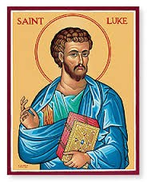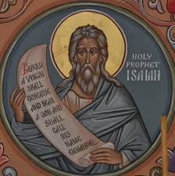
The Connection Between
Isaiah 25-6-9 & Luke 14:21-24

The Connection Between
Isaiah 25-6-9 & Luke 14:21-24

Why did the religious leaders think that
only law-abiding Jews would be there?
This is a 700 year old conversation which begins back in Isaiah 25:6-9.

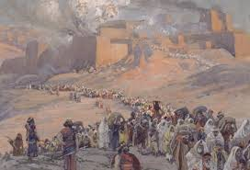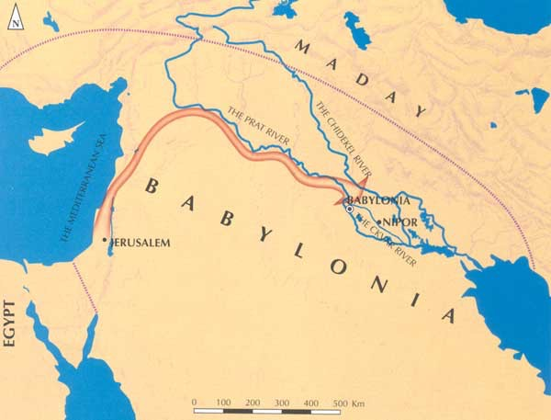

The Historical Context of Isaiah 25

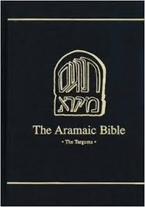

The Historical Context of Isaiah 25

The Isaiah Targum
of the Great Banquet

“Yahweh of hosts will make for all the peoples in this mountain a meal. And
although they supposed it is an honor, it will be a shame for them and great
plagues, plagues from which they will be
unable to escape, plagues whereby they will come to their end.”

Second Century BC:
The Book of Enoch

“But the angel of death with be present to destroy those Gentiles.
The banquet hall will run with their
blood and believers will have to wade through it in order to reach the table!”

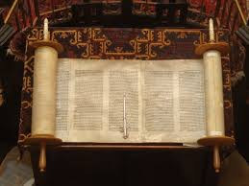
First Century Qumran Community:
The Scroll of the Messianic Rule

The Scroll of the Messianic Rule
and People with Disabilities

“No one can attend the banquet who is smitten in his flesh, or paralyzed in
his feet or hands or lame or blind or deaf or dumb or smitten in his flesh with a visible blemish.”

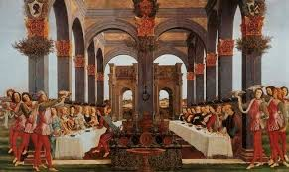

Luke, Jesus, & Isaiah 25

Source

Bailey, Kenneth, Jesus Through Middle Eastern Eyes (Downers Grove: IVP, 2008).
Burge, Gary, Jesus, The Middle Eastern Storyteller (Grand Rapids: Zondervan, 2009), pgs. 43-53.

