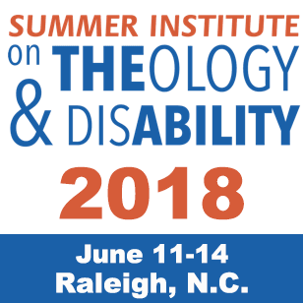
The 9th Summer Institute on Theology
and Disability
Hosted by:
Duke Divinity School and
Edenton Street United Methodist Church
Registration Information and Guide

NOTE: The Registration Website and the Program Website are two different websites.

Registration To Register: Click HERE.
- Registration is slightly higher this year because it includes lunches, and there is no separate meal plan (or charge) for three meals per day.
- There is no registration charge for personal assistants.

Early Bird (Before April 15) | After April 15 – June 1
Standard: $550 | Standard: $650
Student/Seminarian $450 | Student/Seminarian $550
Exhibitor (includes one registration: $800 | $800
Personal Care Assistant | Complimentary ($50 for lunch package and Monday Opening Dinner)
Community Day Monday | $50 (Lunch included)
Individual Days, Tuesday through Thursday | $200
Thursday Evening Barbeque Dinner, Holiday Inn | $30

Scholarships
The scholarships will be our standard $250 credit towards registration costs, primarily for students but some available for people with disabilities. We cannot assist with travel or lodging. And the number of scholarships will depend on sponsorship grants and contributions. Some other options include:
- If you are a person with a disability or a family member, check with your state’s Council on Developmental Disabilities. Some of them have funds to help people with disabilities and family members to attend out of state conferences. Call and ask. They will tell you if there is an online process for applying.
- We welcome gifts or grants for scholarship funds and sponsorships. Contact Bill Gaventa at bill.gaventa@gmail.com.

Lodging : See the Planning Guide on the Summer Institute Website: HERE

CEU’s : CEU’s will be available through Duke Divinity School. Sign up for a CEU Certificate when you register.

Transportation Options To and From Airport In the Planning Guide: HERE

Program Information: Week at a Glance, Workshop and Speaker
Information and Descriptions, go HERE

