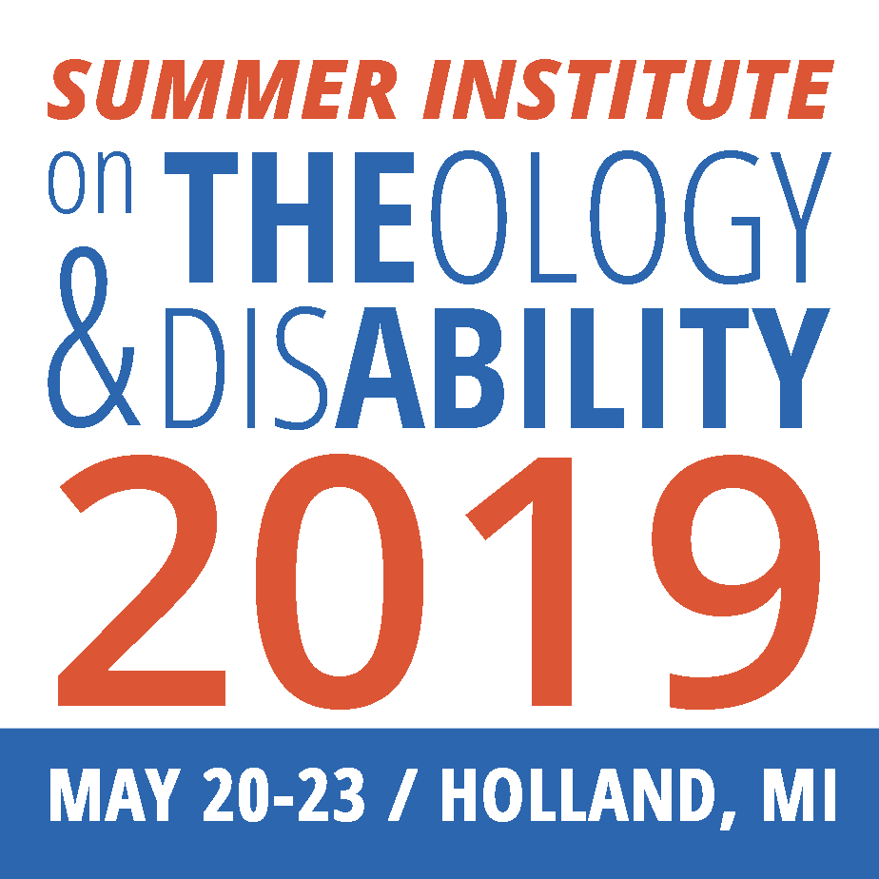
10th Summer Institute on Theology and Disability
Hosted by Western Theological Seminary and Hope College, Holland, MI – May 20-23

Workshop, Poster, and
Roundtable Discussion Proposals

Deadline: January 1, 2019.
Email to Bill.Gaventa@gmail.com

The 2019 Summer Institute will return to Western Theological Seminary and Hope College in Holland, Michigan, where we met in 2016. Lodging will be at Hope College and nearby hotels. Registration costs should be similar to last year, but lodging will be cheaper if you are staying on campus. (See Planning Ahead Guide) Please use this form if you would like to lead a workshop, a Lunchtime Roundtable discussion, or a poster presentation (new this year). Collaborative workshops are encouraged. This year, a leadership team is assisting in the selection and coordination of workshops.

This is form is provided in Word so you can expand it if needed, but please follow word limits where required.
Prefer to submit an online form? Visit bit.ly/2019SITDProposal

Contact Information (Organization and role are optional)
Your Name:
Exactly as you would like it printed, if proposal is accepted, with titles and/or degrees.
(e.g. “Bill Gaventa”, “Rev. Bill Gaventa” or “William Gaventa, M. Div”)
Organization:
Role/Position/Title:
Address:
Email address: |  | Phone #:

A Note on Access
If your proposal is accepted, we will send you guidelines for accessibility. We will also let you know what we need by which date (materials to post for electronic access for computer readers, etc.) Please start thinking about the ways that you would endeavor to make your session as accessible as possible (e.g. handouts; describing images; having full text available; Powerpoint/slides to accompany session, etc.).

Other notes:
- If you are an author of a book or other resource, and want it featured in the Cooperative Resource Exhibit, please let us know.
- Questions? Contact Bill.Gaventa@gmail.com
Workshop, Roundtable Luncheon Discussion, or Poster Information
- There will be one round of workshops in the morning, a second in the afternoon.
- Roundtable Luncheon Discussions take place at lunches, and are times for people who want to network with others around topics, ideas, or shared interests.
- Poster Presentations offer an opportunity to display information about a research project, program, initiative, etc.

Proposed title:
Format preference
(If you are open to other formats, you can select more than one option)

☐ | Luncheon Roundtable discussion
☐ | Poster presentation
☐ | 60 minute workshop
☐ | 75 minute workshop
☐ | If needed, I am willing to work with another registrant if our workshop topics are similar in sharing a time slot. (This would be planned with your input)

Leader/Speaker’s Bio (75 words or less)
Summary of Presentation (100 words or less)

My primary audience(s):
☐ | Scholars, academics and writers
☐ | Clergy/religious professionals
☐ | Lay practitioners and volunteers
☐ | People with disabilities
☐ | Families, friends, and advocates of people with disabilities
☐ | Other:

Are you presenting from particular faith perspective(s) or religious tradition(s)?
If so, please specify:

☐ | Judaism
☐ | Christianity
☐ | Islam
☐ | Other:
My workshop session would be primarily:
(If you are proposing a lunch discussion or poster presentation, you can skip this question.)

☐ | An academic/scholarly lecture
☐ | A presentation
☐ | An interactive workshop
☐ | A discussion/conversation
☐ | Other:

We welcome proposals for alternative workshop formats, such as artistic/meditative/sharing of personal experiences etc.

Audio / Visual Needs

☐ | I will be using Powerpoint
☐ | I can bring my own computer
☐ | Other:

Understanding of Terms
(Your submission of this proposal indicates your agreement with the following)

- You will receive an update on the status of your proposal in January, 2019. Proposals received after January 1st will be considered on first come, first served basis.
- All presentation leaders must register for the Summer Institute. While we wish we had funding to offer discounts for workshop leaders, we currently do not. If finances are an obstacle, please connect with us if you might qualify for a student scholarship or a discount available for people with disabilities.
- Presentation leaders will be responsible to print their own handouts.
Thank you for your interest in participating in the Institute and in facilitating a presentation! We look forward to receiving your proposal and connecting with you in January 2019 with further information.

