Inclusive Worship: Creating a Language and Multisensory Options Where All can Participate

Presenter: Barbara Newman

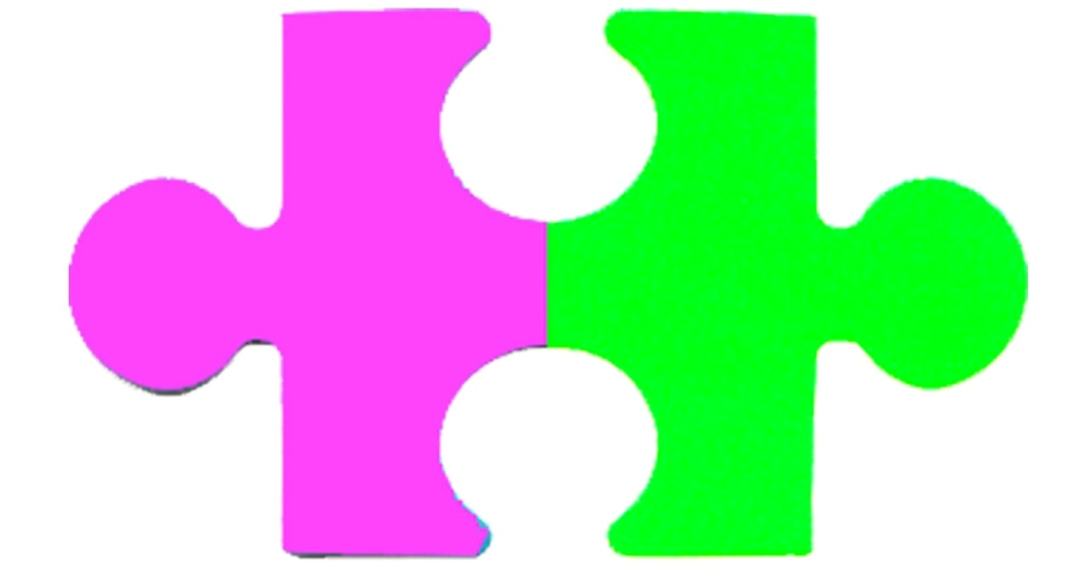

How I started this work

Psalm 139:13

Most important place to Begin –Getting to know the individual

Green and Pink

Asking the right question- What **can** the individual do?

* How does the individual take in information?
* How does the individual get information out
* What movements can the person do?
* Does the individual have sensitivities to sensations?
* What equipment or supports might be needed for this individual?

The Vertical Habits Story

“God’s language school” – Quote from Thomas Long

1. Love You (Praise) –Psalm 47:6-7

Idea bank for “Love You”:

* Wrist Ribbons
* Flags
* Shaky Eggs
* Break Tickets

1. I’m Sorry (Confession)—Psalm 51

Idea bank for “I’m Sorry”:

* Sorry
* I forgive you
* Expectations for behavior

3. I’m Listening –Psalm 119:9-11, 15-16

Idea bank for “I’m Listening”:

* Mutli-Sensory
* BIG IDEA
* Adapted Curriculum, Friendship Ministries Curriculum
* Story Stick, Story Apron
* Speech Buttons
* YouVersion and YouVersion Kids

Vertical Habits in horizontal community (example: Lighthouse Christian Ministries)

Some materials to help you:

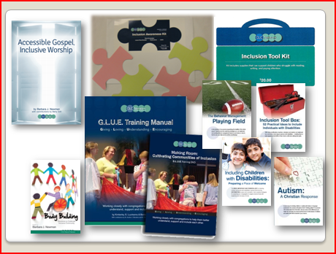Vertical Habits showcase

* <http://worship.calvin.edu/resources/resource-library/showcase-vertical-habits-worship-and-our-faith-vocabulary/>
* <http://psalmsforallseasons.org/vertical-habits>

Connect with CLC Network for further resources:

[www.clcnetwork.org/blog](http://www.clcnetwork.org/blog)

