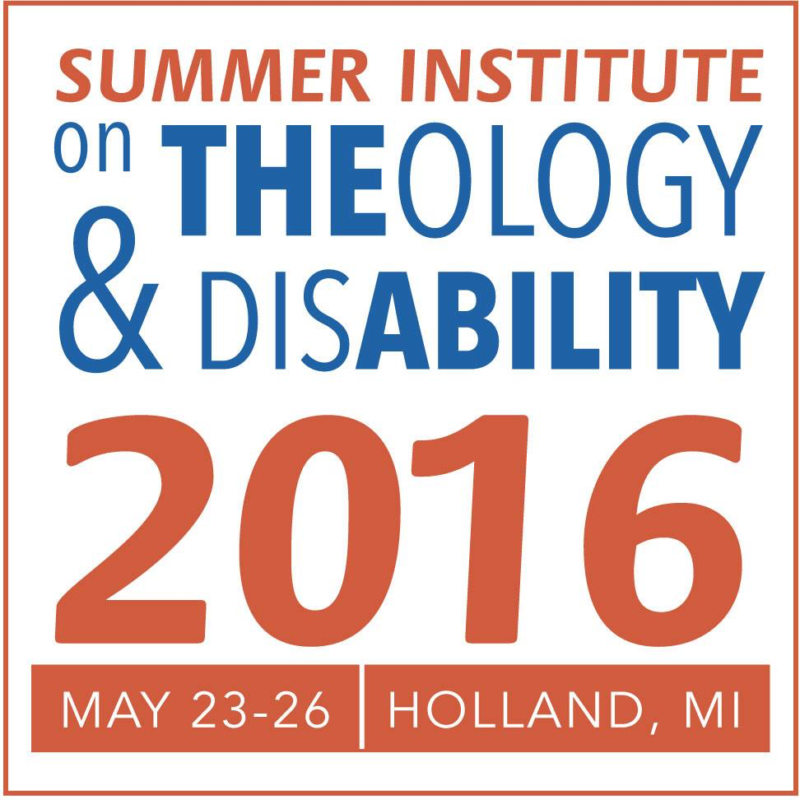
Overview
2016 Summer Institute on Theology and Disability
and
Registration information

We are delighted you are interested in the Summer Institute on Theology and Disability! There are a number of highlights this year:

- An opening “Community Day” with SI-TED talks by the Summer Institute faculty with follow up afternoon discussion groups.
- Plenary sessions on the integration of disability concerns into seminary life and curriculum, ministries with people with intellectual and developmental disabilities, theology and profound disability, a first Ruderman Family Foundation Jewish lecture, and a first Jean Vanier Emerging Scholar lectureship.
- Thirty workshops Tuesday through Thursday along with our Ph.D. student symposium.
- Visits to the Friendship House at Western Theological Seminary and optional excursions with dinner on Wednesday evening.
- The Cooperative Resource Exhibit, luncheon roundtable discussions, and lots of networking.

REGISTRATION
Western Theological Seminary and Hope College are serving as our hosts. The REGISTRATION process is being handled through Hope College, where you can register and reserve lodging at Hope College sites at the same time. The registration website is: http://eventreg.hope.edu/EmsRegics/SITD2016.

SUMMER INSTITUTE INFORMATION
The Summer Institute is now one of the projects of the national Collaborative on Faith and Disability. Our website is http://faithanddisability.org/projects/summer-institute/. Along with this Overview, you will find additional information on the 2016 Summer Institute, including:

- The Week at a Glance schedule, in table form.
- The Weekly Schedule in Word format, no table.
- Scholarship Application Process.
- Cooperative Resource Exhibit Entry Form and Process.
- Listing of the scheduled Workshops. (Days are not yet assigned).
- Information and registration process for leading a roundtable luncheon discussion on a topic of your choosing. (A chance to network with others with similar interests)

SPONSORS
The Summer Institute could not happen without sponsorships. We are very grateful to our current sponsors: the Myers Foundation of Holland, Michigan, the Ruderman Family Foundation of Boston, the Developmental Disabilities Institute at Wayne State University in Michigan, the Calvin Institute for Christian Worship in Grand Rapids and the ELCA Disabilities Ministries Team. Additional sponsors are welcome. Sponsors enable additional scholarships and ongoing planning for the Summer Institutes. For information, contact Bill Gaventa, Director, at bill.gaventa@gmail.com

