3145 Benham Ave., Ste. 5
Elkhart, IN 46517-1970
Phone/Fax: 1-877-214-9838
Email: adnet@adnetonline.org
Website: www.adnetonline.org

Circles of Love: Encouraging Congregational Networks of Care
for People with Disabilities and their Families

Presenter: Christine Guth, christine@adnetonline.org, 574-343-1362
Summer Institute for Theology and Disability – workshop
May 2016

50 Word Abstract
Congregations can supplement the support provided by secular service systems when they respond intentionally to the needs of persons living with disability and their families. Presenters outline a vision and share stories and strategies from congregations that have intentionally created networks to provide members with various kinds of long-term support.

Outline and notes
- Check – does anyone need a partner to assist with visual description or audio help?
- Any other disability accommodation needs I should be aware of?
- Circles of Love – a book of stories. I will start by sharing a couple of the stories, then step back to give more of the book’s wider context.

  - Story 1: God’s Eye Art and South Side Mennonite
    - I met Chad first through his art, marketed by his church friends under God’s Eye Art.
    - Chad, was an artist from young age, developed increasing physical disabilities
    - Pastor issued call to his congregation to consider how to help Chad live out his call
    - Committee formed to consider, with Chad and his mother, how the church could be helpful
    - Greatest perceived need: help developing and marketing Chad’s art.
    - For-profit Corporation formed –team formed its board of directors
    - Investors: members of church raised $5,000 capital, no financial return expected
    - Purchasing art supplies, framing, exhibits and sales, line of greeting cards
    - Income covered Chad’s art supplies, lessons, and paid Chad a stipend.
    - Lasted 20 years, $115,000 gross sales. Processed nearly 1000 paintings.
    - God’s Eye Art ended when Chad’s health deteriorated so much he could no longer paint. He died in 2013 at age of 46.

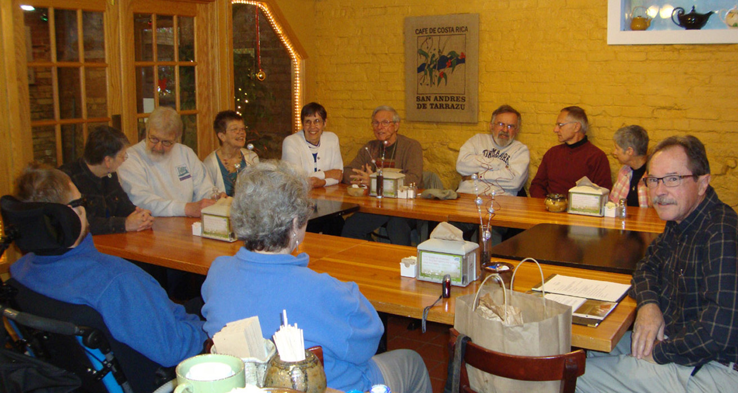
Caption: God’s Eye Art Shareholders Meeting.
Description: Eleven people engaging in conversation sit around wooden tables arranged in a U shape in a restaurant meeting room. On the left, with his back toward the camera, is a man sitting partially inclined in a wheelchair with a headrest. On the tables are napkin dispensers and packets of sugar, salt and pepper.

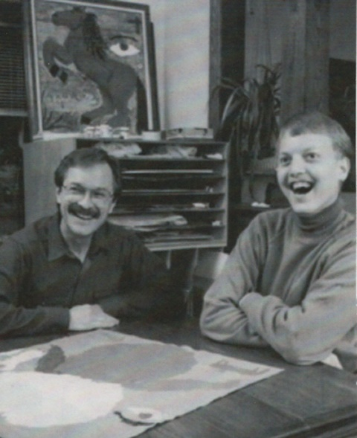
Caption (left): Dean Preheim Bartel and Chad Friesen at the beginning of God’s Eye Art
Two young men are sitting at a table covered by a large poster or painting. The man on the right is perhaps a teenager, smiling very wide. Behind them is a set of shelving and a painting of a rearing horse.

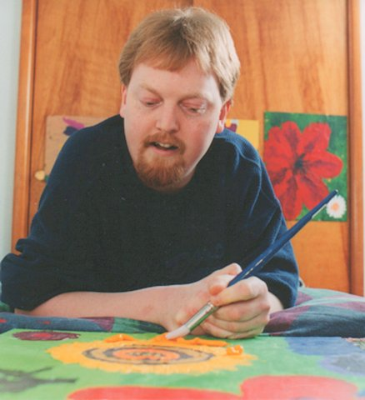
Caption: Chad working on a painting.
Description: A man in his 20s leans on his elbows over a painting with bright yellow and red figures on a green background. He grips the paintbursh with one hand and uses the other hand to steady his arm. One the wall is a painting of a bright red flower.

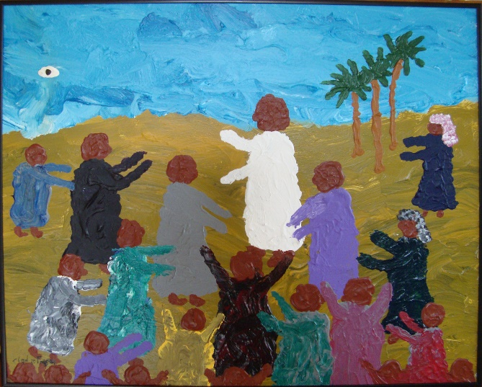
Left and Below: A few of Chad’s paintings
The Crowds Following Jesus
Description: Painting of a group of about a dozen figures, painted as general shapes, without facial details. In the center a figure in white has arms outstretched. In the blue sky is the shape of an eye.

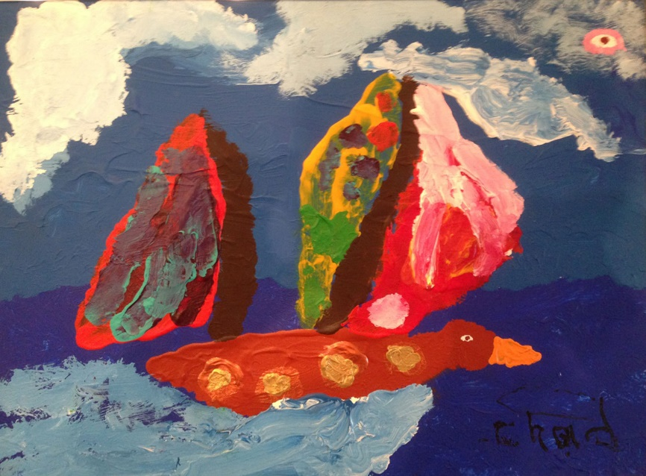
Going with the Wind
Description: Painting of a sailboat with the boat's body suggestive of a duck in flight and the wings are the sails. God's eye in the corner of the sky.

Water Lilies
Description: Abstract painting with shapes suggesting flowers. Large red flower with black center. Round green circles with pink flowers suggest lily pads. In one corner of a cloudy, turbulent sky is a small white eye.

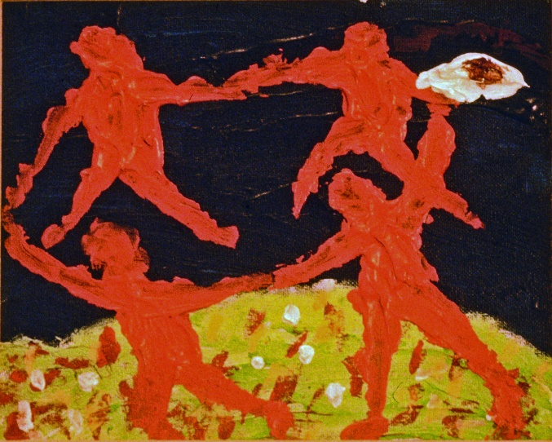
Circle of Love, a painting that inspired the name of our book.
Description: Four abstract human figures hold hands in a circle. Two of them appear to be leaping above the ground. In the corner of the black background is a large red, white, and black eye.

  - Story 2: The Larson family and Olive Mennonite Church
    - I first became acquainted with the family when one of the pastors contacted me
    - Son had turned 18 and suddenly his SSI payments had stopped – and the family was without income.
    - Mom is blind, son had developmental disabilities.
    - Pastor came to me asking for information about public resources for people with disabilities and how to obtain them
    - I discovered a congregation that was already fully involved in supporting the Larson family after the father’s sudden death a few years earlier. One need had led to the next: crisis-focused at first, then long-term needs.
    - 3 subgroups organized – one focused on needs of son, one for mother, and one for the young adult daughters.
    - Support included: firewood, change in housing, obtaining secular disability supports and services, financial management and planning, young men for the son to hang out with, emotional support, drawing adult daughters into support network
Below left: Sharon and Kevin Yoder, pastors at Olive Mennonite Church
Below right: Support team for the Larson family sit around a dining room table (13 people).

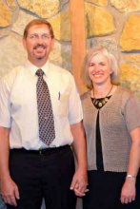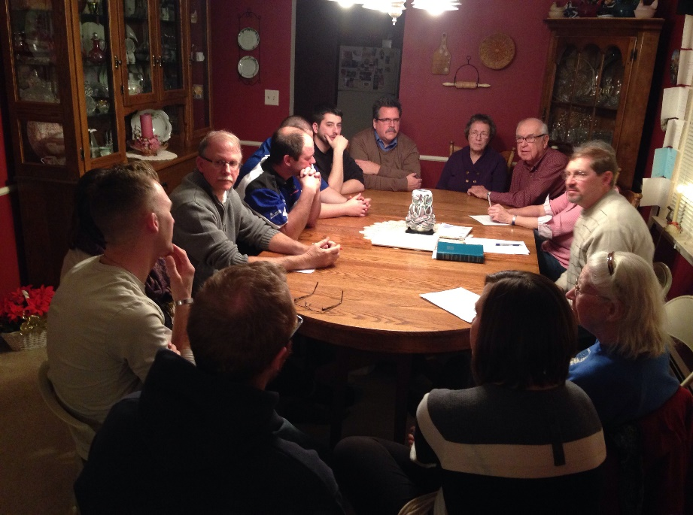

- Our books:
  - Supportive Care in the Congregation: Providing a congregational network of care for persons with significant disabilities
    - Outlined a vision, rationale
    - Written 1986, revised 2011 with all-updated extensive resources
  - Circles of Love: Stories of congregations caring for people with disabilities and their families. –
    - Practical examples of implementation of Supportive Care in the Congregation’s vision.
    - Published 2015.
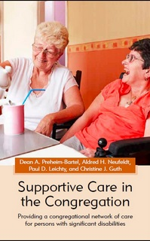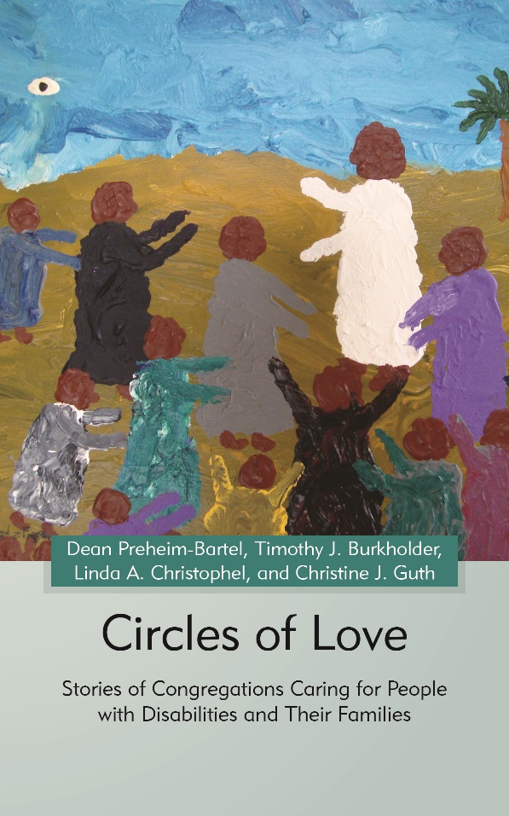
Above: Book covers, Supportive Care in the Congregation and Circles of Love
Descriptions:
Supportive Care in the Congregation. Subtitle: "Providing a congregational network of care for persons with significant disabilities. Authors are Dean A. Preheim Bartel, Aldred H. Neufeldt, Paul D. Leichty, and Christine J. Guth. A photo shows an older woman pouring water into a glass with a straw. Seated next to her in a power wheelchair is a laughing young woman in an orange blouse.
Circles of Love. Subtitle: Stories of congregations caring for people with disabilities and their families. Authors are Dean Preheim-Bartel, Timothy J. Burkholder, Linda A. Christophel, and Christine J. Guth. The image is an abstract painting of a group of about a dozen figures. In the center a figure in white has arms outstretched. In the blue sky is the shape of an eye.
  - What is a Supportive Care Group (Circle of Love)/
    - Intentional effort within faith community
    - to provide some of the supports a person with a disability (and/or family) needs
    - Consideration of daily living needs, more than simply church participation
  - Essential elements
      - Relationships: a plan for support of persons with disabilities in the context of congregational life, capitalizing on and strengthening existing relationship networks.
      - Leadership, someone with a vision who is able to mobilize and organize others
      - Participation: Person(s) affected participate to maximum extend possible or desired. Self direction.
      - Identifying a reasonable focus: What needs can the congregation feasibly meet?
      - Matching gifts to needs: Who might God call who has needed gifts?
      - faith convictions of participants undergird committed service

    - Functions may include
      - reduce isolation,
      - relieve burden on family members,
      - connect to wider community supports
      - Cultivate gifts of person with a disability
    - Anabaptist theological themes
      - Salvation does not occur in isolation but in the context of human community
      - a vision that the new community transformed by Christ is the first fruits of God’s promised reign
      - Embodied discipleship – Christians truly know Christ by following him in life.
      - Life of Christian service is a calling for all Christians.

  - Successful efforts we have observed usually entail:
    - Customizing: Using the model as ideas to select from, not blueprint
    - collaborating with secular resources
    - Being initially motivated by crisis, but planning beyond crisis for a sustainable plan
    - Strong leadership and vision to get it started
    - Using gifts/interests of team members, limiting responsibilities carried by each person
    - Building relationships with entire family unit
    - The least amount of bureaucracy that still gets the job done
    - Open-ended time commitment, phasing out when no longer needed
    - Recognizing that ministry is two-way: givers are receivers, vice versa
- More stories as time allows

  - Anita – Columbus Mennonite – a story not in the book
    - “brotherly agreement” to look after Anita after her parents’ death.
    - Church worked with surviving family members and service agencies to make sure Anita’s needs were cared for over many years
    - Anita died earlier this month at the age of 62.
Description: A song written by Anita and often requested by her to be sung in worship. Love is a beautiful thing. Let’s spread it all over. Love is catching on. Let’s pass it on, pass it on, pass it on.

  - Informal network – a story not in the book. Support networks need not be complex to make a difference.
    - Guth family – Eighth Street Mennonite
      - One coordinator, four team members
      - Mom as “keystone species.” (When a keystone species is removed from a habitat, the habitat is dramatically changed. All other species are affected )
      - one church member was able to rally and facilitate support of a few others
      - Result: A weekly time out with a friend, lasted years, until kids left home
      - Later - Friends to call on for help in moving, cleaning out apartments
      - One coordinator, four team members
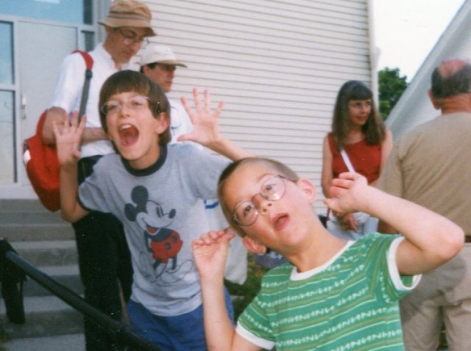
My two children – and husband on the left in about 1996.
Description: two children, about ages 5 and 8 make silly faces at camera. A few adults in the background.

  - Kent– supporting independence
    - A supportive care group for Kent was a pilot project for the model when Supportive Care in the Congregation was being developed in 1985, in response to crisis.
    - Book author Dean Preheim-Bartel collaborated with Kent’s pastor to get group set up.
    - Each participant committed to specific responsibilities, open ended basis.
      - Menus and shopping
      - Assistance with relationships
      - Taking Kent to social events and activities
      - Financial management
      - Employment assistance
      - Housing
      - Regular phone calls to check in
    - Group met monthly at first, then less often.
    - Formal group lasted 10 years, when no longer needed. Relationships continue decades later.
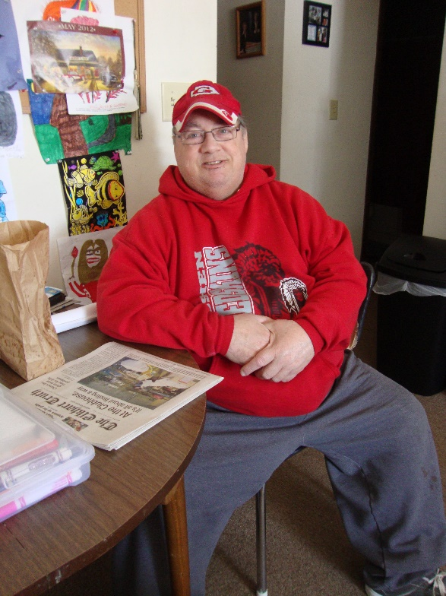
Kent in his apartment in 2014
Description: Large middle-aged man wearing a red hooded sweatshirt and a baseball cap, seated at a kitchen table. On the table are a newspaper, small plastic boxes, and a paper sack. Pictures are tacked on a bulletin board behind him.

  - Ben and Pleasant View Mennonite
    - When I first heard about Ben, he was living in subsidized housing where he was being preyed on by drug dealers. Any furnishings his parents provided him in his apartment were quickly exchanged for drugs. Bare apartment.
    - Deeply caring family but aggression made it unsafe for him to live with parents. Ben lives with mental health and intellectual disabilities.
    - Dad uses a wheelchair after a serious auto accident.
    - Sad series of events: lost lease due to drugs, lived in homeless shelter for a year
    - Parents explored with pastor the possibility of church forming a support group for the family
    - Shared story with groups in the congregation, eventually formed a support group of about a dozen who felt called to help.
    - After 12 years, Group continues to assist with
      - Housing, spring cleaning
      - Meals and checking in when parents are out of town (often)
      - Social activities
    - In new housing drug dealers are no longer a problem, dad who uses a wheelchair can visit since apartment is accessible.
    - Support team is a model for other groups forming in the congregation
    - Ben often shares with a sense of excitement when different ones have stopped in to connect with him and bless him in some way.
Below left: Ben (Large man with trim beard wearing a Notre Dame t-shirt).
Below right: Ben and his parents and brothers
(Family portrait on the front porch. Dad uses a wheelchair. Mom stands behind dad with hands on his shoulders. Also with them are three young men, one wearing a Cubs jacket.)
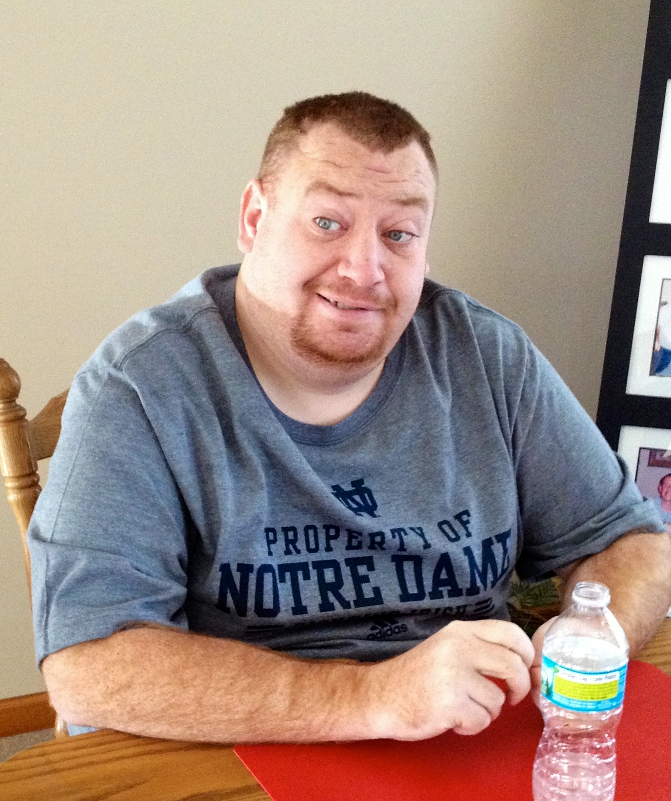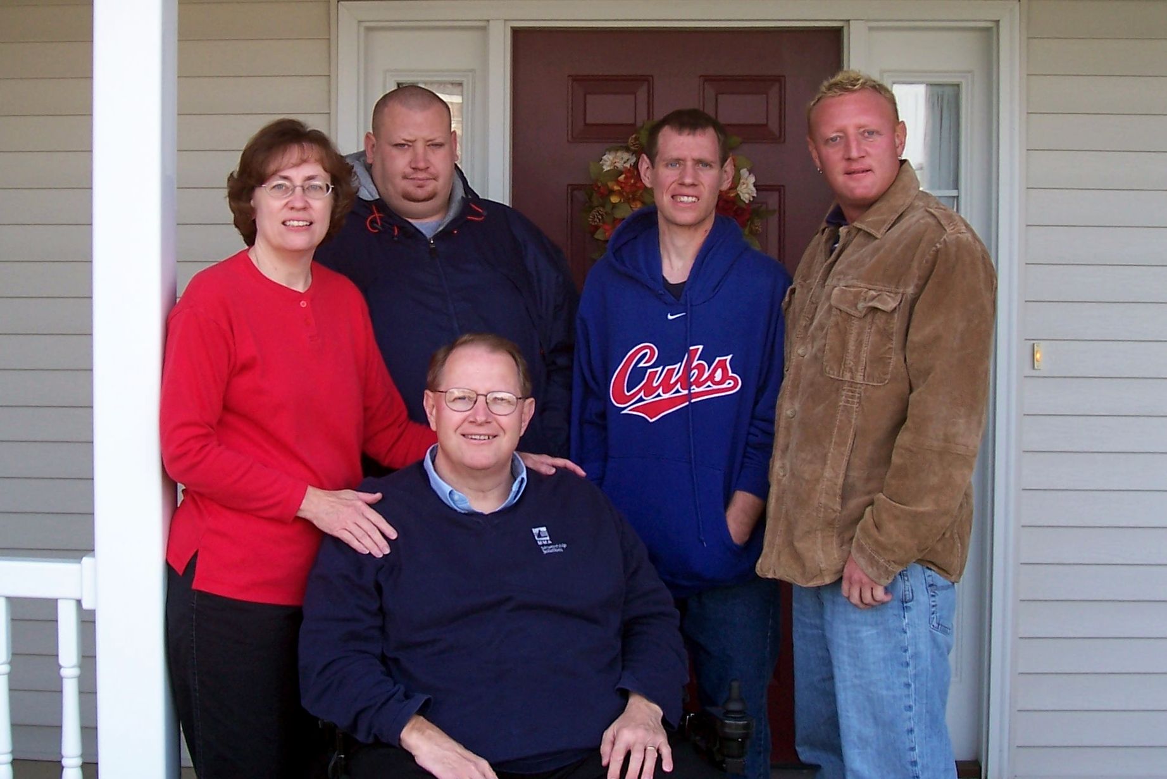
Below: Ben’s support team in the early days.
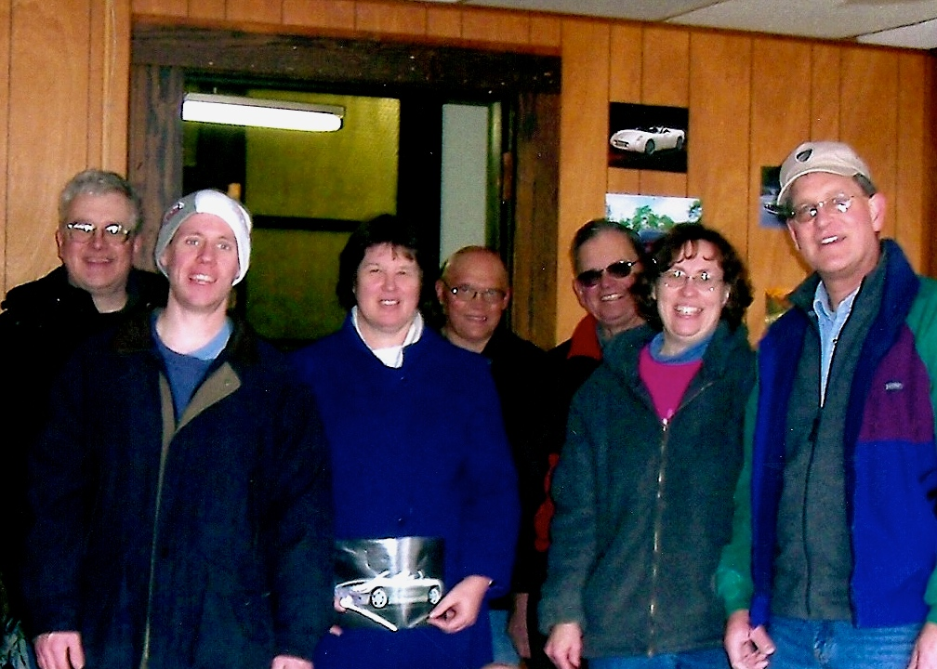
Description: Five men and two women pose for a group shot. They are wearing winter coats. On the wall behind them are pictures of race cars.

Discussion: What opportunities can you think of for a Circle of Love in your context?
What obstacles stand in the way?
What is one concrete step you can take to explore a Circle of Love in your context?

