Spirituality and persons with profound intellectual disabilities…

Dr Jill Harshaw Queen’s University Belfast

“Severely mentally handicapped people are denied the very substance of a rational productive existence...Such an existence gives no real opportunity for inner spiritual growth, or the nourishment of the human spirit, both of which are important when coming to terms with the meaning of Christianity. It gives no real opportunity to experience the joy of seeking a lifetime relationship with the Almighty, because concepts involved are complicated and require a level of awareness which the profoundly mentally handicapped do not have.” Birchenall

Dr Jill Harshaw Queen’s University Belfast

Initial tensions

Labels

- Generalising

- Speaking about v speaking for

Intelligence Quotient

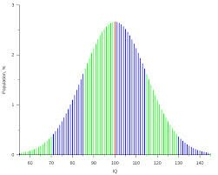
People with profound intellectual disabilities

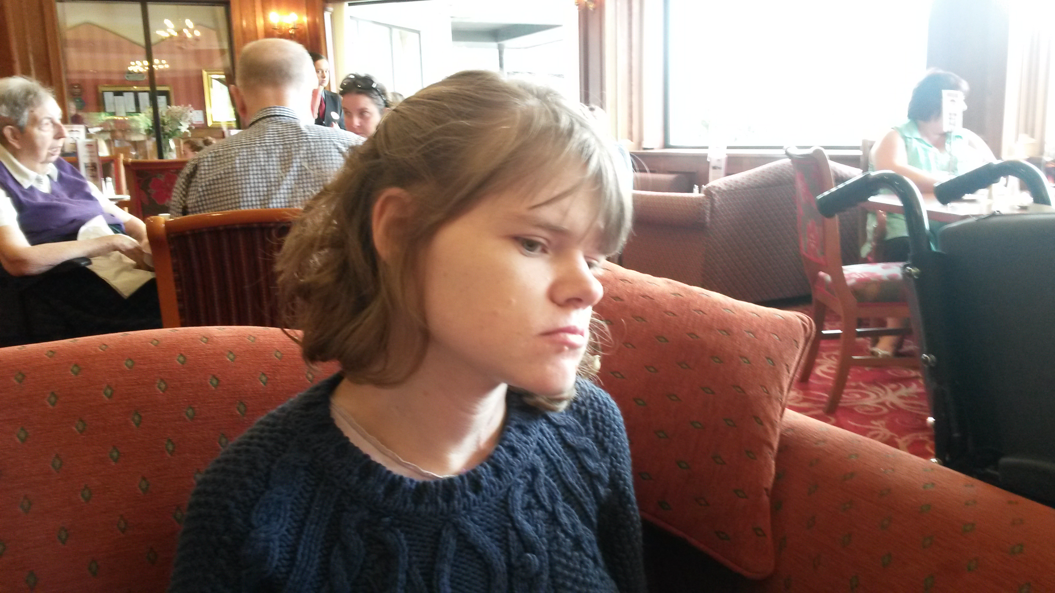

anthropology?

vulnerability?

ecclesiology?

sign?

prophecy?
community?

The spiritual experience of people with
profound intellectual disabilities…
“what is assumed…in practice, however much we might wish to redefine what faith is, is that in order to be saved, a person will normally have language and the intellectual capacities to learn a set of beliefs and make choices and decisions about them; what is assumed is able-bodied normativity.” Morris

Faith comes from hearing and hearing comes by the Word of God…

Potential responses…
- Prevenient grace
- Sacrament of baptism
- Age of understanding

Focus on eternal security

Another potential response…

Empirical evidence

Focus on spiritual experience
The elevation of the anecdote?

“severely mentally handicapped people are denied the very substance of a rational productive existence...Such an existence gives no real opportunity for inner spiritual growth, or the nourishment of the human spirit, both of which are important when coming to terms with the meaning of Christianity. It gives no real opportunity to experience the joy of seeking a lifetime relationship with the Almighty, because concepts involved are complicated and require a level of awareness which the profoundly mentally handicapped do not have.” Birchenall

Spirituality and persons with profound intellectual disabilities…

…through the lens of a ‘theology of accommodation’

Accommodation
  - The provision of a room or lodgings
  - The process of adapting or adjusting to someone or something

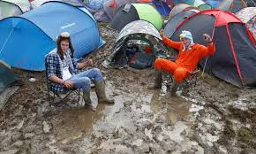

The premise of divine accommodation
- God is infinite
- God created human beings to be in loving relationship with himself
- These human beings are finite and are therefore
incapable of apprehending the infinite God – there is, humanly-speaking, an unbridgeable gap between them and God.
- Because God loves us, in order to bridge this gap, He accommodates His Self-revelation to what human beings are capable of apprehending of Him.

Outside the biblical tradition
“the ancient Romans used the word [accommodation]...in rhetoric to
express the idea that an orator would adapt himself to his audience in his choice of words, gestures and emotions so that he could move their hearts and persuade their minds in
whatever direction he wanted.” Van Bemmelin

Accommodation within the biblical tradition
- potential discrepancies within the text

- differences between what God asks of humans in one period and context and what He expects in another

- the fact that God chooses to use human language at all

- Scriptura humane loquitor: “theology…stoops to speak the language of ordinary men."

“John spoke of the matter not as it is but even he, only as he was able…it was a man that spoke of God. Inspired indeed by God, but still a man. Because he was a man he said something; if he had not been inspired he would have said nothing. But because he was a man inspired, he spoke not the whole, but what a man could, he spoke.”
Augustine

Ezekiel 20
“I gave them my decrees and made known to them my laws, by which, the person who obeys them shall live.
Moreover also I gave them my Sabbaths, as a sign between us, so they would know that I the Lord made them holy.” (11-12)

“I gave them other statutes that were not good and laws through which they could not live; I defiled them through their gifts – the sacrifice of every firstborn – that I might fill them with horror so that they would know that I am the Lord.” (24-25)

“For who is so devoid of intellect as not to understand that God, in so speaking, lisps with us as nurses are wont to do with little children? Such modes of expression do not so much express what kind of a being God is as accommodate the knowledge of him to our feebleness. In so doing He must, of course, stoop far below His proper height.”
John Calvin

Anthropomorphic depictions of God

“it is a well-considered design that the Holy Scripture speaks of God as of a being resembling man, and ascribes to him a face, eyes, ears…This is done out of consideration for man’s power of comprehension.”
Seisenberger

The motivation for accommodation?
…The love of God

We account for God’s willingness to admit men to communion with Himself by His love towards mankind. But since that which is by nature finite cannot rise above its prescribed limits or lay hold upon the Superior Nature of the Most High, on this account, He, bringing His power, so full of love for humanity down to the level of human weakness.
Gregory of Nyssa

“so the Divine power..., though exalted far above our nature and inaccessible to all approach, like a tender mother who joins in the inarticulate utterances of her babe, gives to our human nature what it is capable of receiving and thus in the various manifestations of God to man he both adapts Himself to man and speaks in human language and assumes wrath and pity and such– -like emotions so that through feelings corresponding to our own infantile life, might be led as by the hand, and lay hold of the Divine nature by means of words which His foresight has given.”
Gregory of Nyssa

So what are we saying?

- God’s way of accommodating is flexible
- God chooses to stoop to human levels of understanding
- God’s accommodation shows the intensity of God’s desire for relationship with human beings.
- Words are not the reality – just signs pointing towards the reality

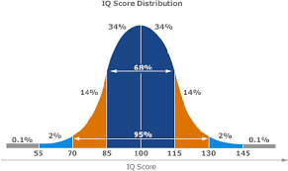
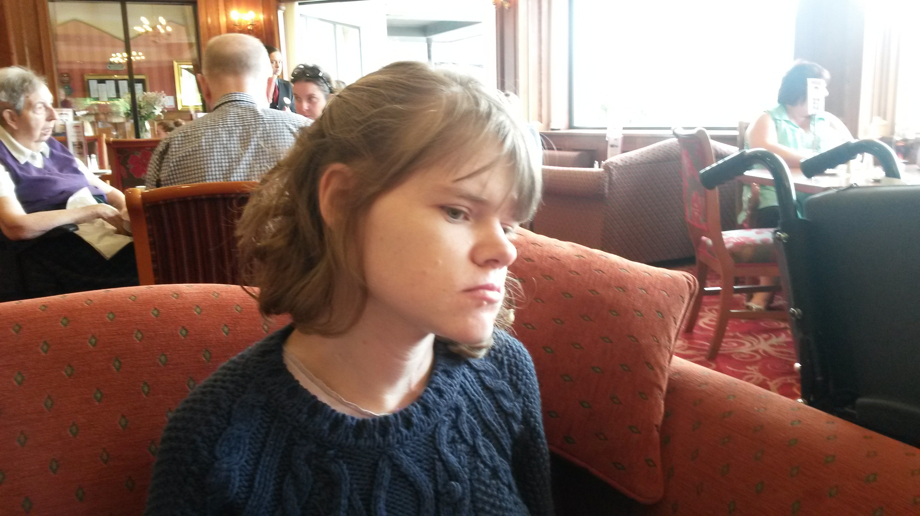
At what point on the 1Q spectrum does God’s accommodation stop?
(Or in other words, how clever do
we need to be for God
to be able to
or want to draw us
into His love?)

Here?
Here?
Here?

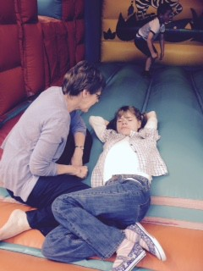
STARTING WITH THE WRONG QUESTION

Encountering God is not about the extent of human incapacity but about God’s unlimited capacity and endless desire to draw people into His love.

Just because we cannot work out how that happens or what it looks like does not mean it does not exist!!!

The infiniteness of our ignorance

“We try to measure God’s immeasurableness by our small measure. But it is God who knows the incalculable difference in measure between His infinity and our finiteness, and accordingly accommodates the one to the other in the way in which he reveals Himself to us.”
Battles

Contrasting God’s accommodation with ours:

An unhealthy inquisitiveness into the heart of people?

Humility in the academies

“Intellectual activities may lead us part of the way; they may even point to God’s existence, but God’s essence is beyond our powers of expression. Enfleshed human beings do not have the capacity to grasp God’s nature except in faithful acceptance of the mystery.”
Norris

“The world is immense, constructed on no plan or theory which the intellect of man may grasp. The transcendent is everywhere. This is the burden of every verse. Sufficient of insufficient there is nothing more…God is great, we do not know his ways.”
Rutherford

“Don’t just do something – stand there…”
Pattison

