The Great Invisible Disability:

Hearing Loss

David G. Myers

Summer Institute on Theology and Disability

A caveat

I am not a hearing professional (ENT physician or audiologist/hearing specialist)
- I am a
  - psychologist
  - person with hearing loss
  - hearing advocate

The Wonders of Hearing

The Cinderella sense--the poor sister
  - vision gets 10 times the brain area
  - millions of photoreceptors vs. 16,000 hair cells

Wireless mind-to-mind communication
  - Imagine an alien species that passes thoughts from one head to another by pulsating air molecules . . . science fiction?

Hearing “bottom-up”

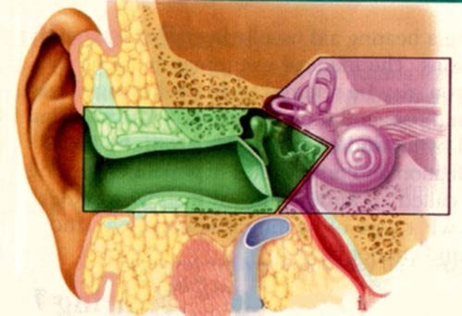Fox Valley Hearing Center, Inc
5/1/2016 4

The brain: perceiving sound

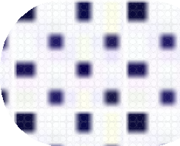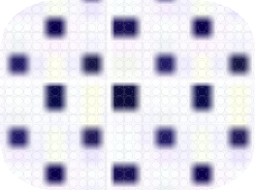Outer ear: collecting air pressure waves
Middle ear: mechanical waves
Inner ear:
fluid waves
Auditory nerve: electrical waves

Top-Down Perception

A BIRD IN THE
THE HAND

Perceptual set: Top-down hearing

(there is much more to hearing than meets the ear)
- “. . . bad sects”
- interpretive brain, in a microsecond, fills in gaps
  - “Meteorologist” or “Meaty urologist”
  - “Rhapsody” or “Rap City”
  - “The stuff he knows” or “The stuffy nose”

BBC Comedy: The Two Ronnies

“Four candles” • “Fork handles”

Affectionate Spoof of Songs of Praise
By Adam Buxton

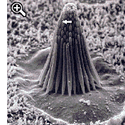

The Magical Hair Cells
- So sensitive . . . and delicate
- Most adult hearing loss is damaged or atrophied hair cells
- May respond to loud sounds but not soft
- May, by “recruitment” of adjacent hair cells, actually become more sensitive to loud sounds
- Increased loss b/c of headsets, power tools, etc.

“Approximately 17 percent (36 million) of American adults report some degree of hearing loss.” (www.nidcd.nih.gov/health/statistics/Pages/quick.aspx, 2012)

48 million (> 25 db loss in one ear)
(National Health and Nutritional Examination Surveys, 2011)

The invisible disability

Americans with Hearing Loss (from National Health and
Nutritional Examination Surveys, audiometric testing 2001-2008)

100%

90%

80%

70%

60%

50%

40%

30%

20%

10%

0%
10 to 19 20s 30s 40s 50s 60s 70s 80+
Frank R. Lin et al., Arch Intern Med, 2011

A note on labeling:

As we now refer not to “the disabled” but to “people with disabilities” (recognizing that the disability doesn’t define the person), so also the hearing loss community
  - “hearing impaired” ☹
  - “hard of hearing” or “person with hearing loss” ☺

What hearing loss might look like visually

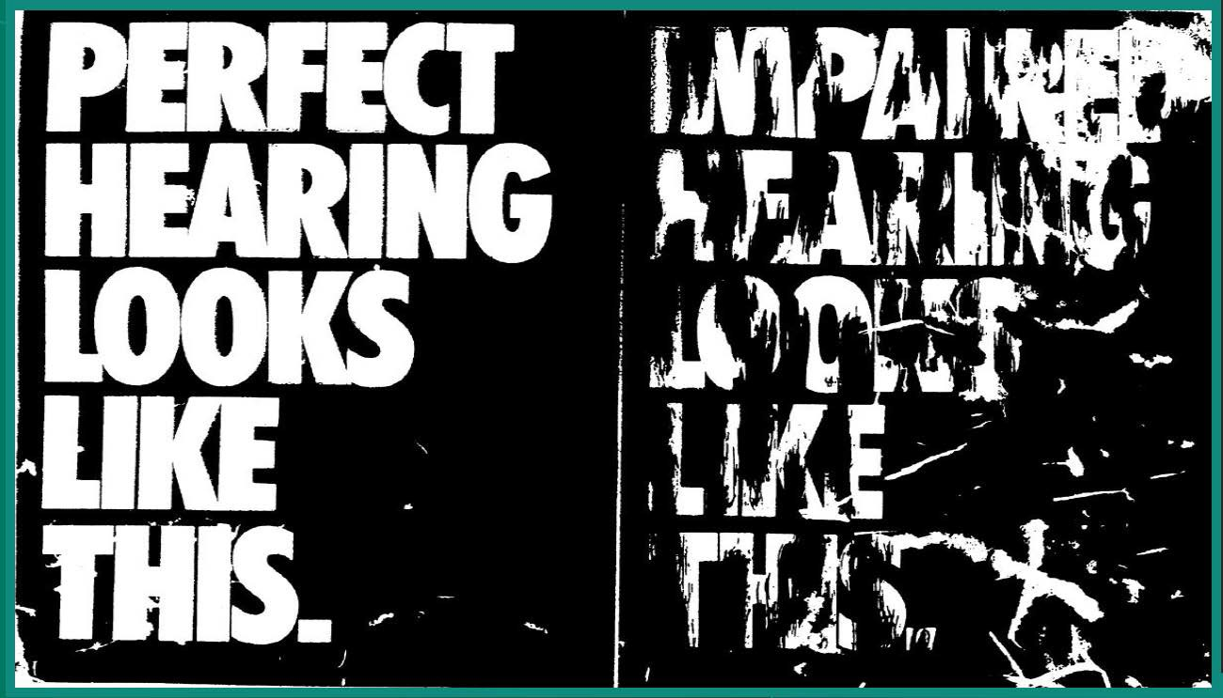Fox Valley Hearing Center, Inc
5/1/2016 15

- The ship left on a three week cruise.
- The shiplefona threeweecruise

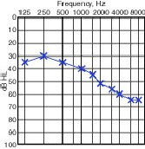

Hi frequency hearing loss:

No hearing loss:

www.npr.org/blogs/health/2013/04/06/175945670/the
-real-sounds-of-hearing-loss

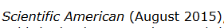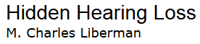

Why do people with hearing loss hear noise (as measured by audiogram) but not comprehend speech in noise?
- Noise may damage auditory nerve, leaving hair cells and audiogram unaffected
- Thus “two people with similar audiograms can perform very differently on so-called speech-in- noise tests.”

Am I . . . are you . . . hard of hearing?
  - We do just fine, thank you, when people speak up, face us, speak distinctly, in quiet settings, etc.
  - Yet . . .
    - we sometimes cup an ear to hear
    - family members say “you’ve got that awfully loud”
    - in conversation we sometimes
      - find others mumbling
      - ask people to repeat
      - talk loudly
      - don’t talk (& risk interrupting or repeating)
      - fake hearing

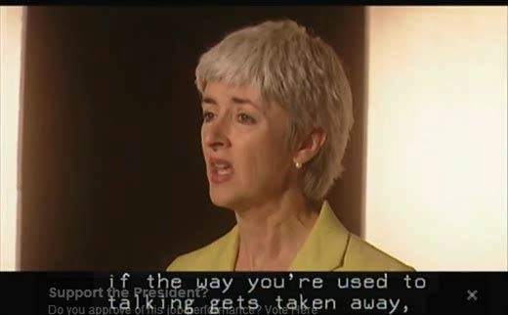How we cope: Bluffing (Gael Hannen)

Percent Who are Sad or Depressed
(2+ weeks, past year, from National Council on Aging survey
of 2,304 hard of hearing & 2,090 spouses, family, or close friends)

40%

30%

Hearing-aid user Non user

20%

10%

0%
Mild Loss Severe Loss

N DCD Researchers Fi d Strong Link Between Hea ing Loss and Depression in Adults
PUBLISHED Of4 MARCH 11, 2014

Cochlear Implants Reduce Depression
Percent Not Depressed
80%

70%

60%

50%

40%

30%

20%

10%

0%
Before cochlear implant After cochlear implant
94 elderly French patients; Mosnier et al., 2015

50%

40%
Percent Who Participate
Regularly in Social Activities
Hearing-aid user Non user

30%

20%

10%

0%
Mild Loss Severe Loss

Percent Who Say that People Get Angry with Them for No Reason
40%

30%
Hearing-aid user
Non user

20%

10%

0%
Mild Loss Severe Loss

Quality of Life Benefits Associated with
Hearing Aids

Decreased
- Anger & frustration
- Depression
- Introversion
- Discrimination
- Anxiety
- Social phobias
- Self-criticism
- Paranoia
Increased
  - Overall health
  - Cognitive functioning
  - Earning power
  - Emotional stability
  - Control of life
  - Interpersonal relationships
  - Social activity
From S. Kochkin & C. Rogin, “Quantifying the Obvious: The Impact of Hearing Instruments on Qualify of Life,” Hearing Review, 2000

My sister, described by a family
member after getting new hearing aids
(October, 2015)

Last night was “a BRAND NEW aunt Nancy. Both Julie and I looked at each other, out of nowhere, and blinked. She talked, she smiled, she socialized, she participated. The deadpan face I have just become used to, was gone.”

Hearing Loss and Inci,dent Dementia
Frank R. Lin, MD PhD; E. Jeffrey Mrett€"r, MD·Ric hard ]. O'Brien MD, PhD;
- usan M. R1esntck PhD; Af an B. Zonderman; PhD· Lui,gi Ferruf ci MD PhD1

So why don’t more people wear
hearing aids--glasses for the ears?

36-48 million with hearing loss
  - 8.4 million with hearing aids

And why the 6 year delay after hearing loss?

- Denial?
- Ignorance of things unheard (what’s unnoticed is not scored as a “miss”)
- Awareness of what we do hear (depends on situation)
- Ignorance of how others hear voices, music, TV, etc.
- Attributing problems to noise, mumbling, soft voice
- Imperceptibly slow decline
- Cost

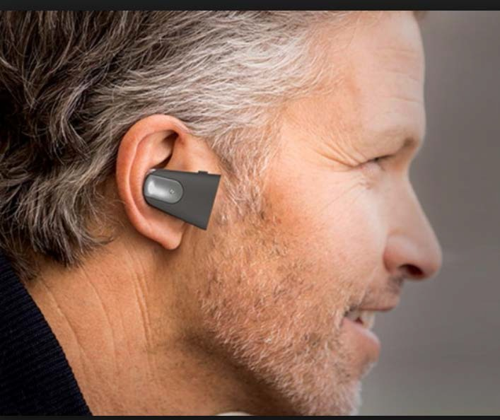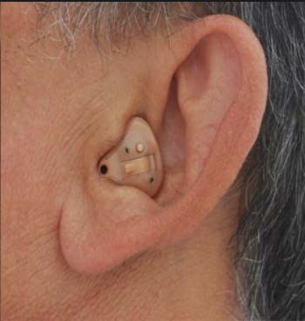PSAPs: Personal Sound Amplification
Products (~$300)
(also wireless headphones: aka “Hearables” or “Wearables”)

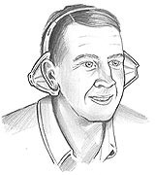

A really low cost alternative . . .

Come Again? With Hearing Helpers, You Hear It the First Time

$9.95

Use of Hearing Aids by Adults with Hearing Loss
Rate per 1,000 population f Increase Desired
350 .. . .. .. .. .. ... ..... ..... ..... ..... ..... ..... .. .. .. .. .. .. .. .. ..... ..... ..

300
250

200
150 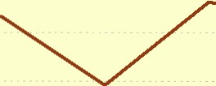
100
50
Adults 70+ years

Adults 20-69 years

0
2001 2002 2003 2004 2005 2006 2007

Source: Richard J. Klein, National Center for Health Statistics, 2008

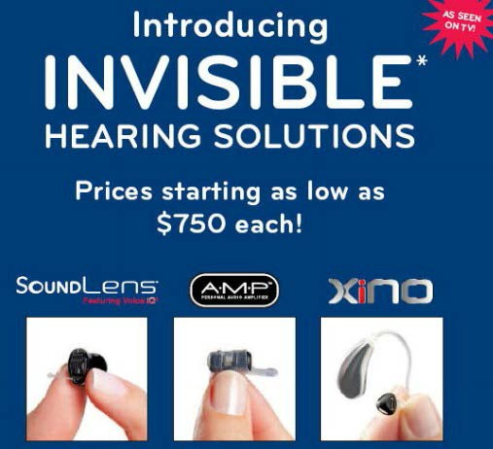Vanity?

  - A visible hearing aid makes us out of the closest
  - Association with aging
  - Actually, our hearing loss may be more socially conspicuous than an aid
  - The “spotlight effect”-- fewer notice our bad hair, dorky T-shirt, etc. than we self-consciously imagine

What you can do for us

- Invite us to quiet places--e.g., carpeted restaurants, with booths
- Rephrase
- Sensory interaction: We are natural lip readers
  - Smell + taste = experienced taste
  - Sight + sound = experienced sound (the McGurk effect)

What you can do for us

- Invite us to quiet places--e.g., carpeted restaurants, with booths
- Rephrase
- tight & fight won’t be confused
- cot/got, sip/zip, toe/doe will be

What you can do for us

- Invite us to quiet places--e.g., carpeted restaurants, with booths
- Rephrase
- tight & fight won’t be confused
- cot/got, sip/zip, toe/doe will be
- restate “Do you want something from the store?” as “Is there anything you want at Family Fare?”
- Create a context (e.g., with visual aids)
- Speak slowly (parse words)

What you can do for us

- Create quiet restaurants, offices, etc.--with sound- absorbing materials
- Do not ask, “Can everybody hear me?”
– There is only one possible answer! ☺

If offered a mic, use it
- Hold mic to mouth

What we (people with hearing loss) can
do for ourselves
  - Be out-of-the-closet: “I am HOH; it would help me if we could be seated in a quiet corner . . . If we could have the music down”
  - Choose
    - light places
    - quiet places
    - corners

Group seats close together (minimize speaker-to- listener distance)
- Sit front and center

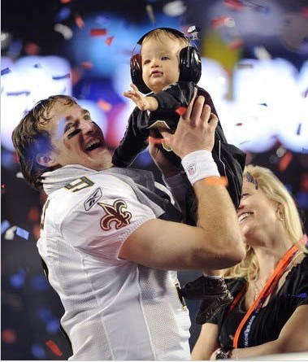

- Protect our ears
- Harness the new assistive technologies

Hearing loss myth:

Late-deafened and hard of hearing people are part of the Deaf community, know Sign language, and use interpreters.
- Not so!

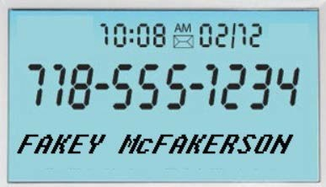

Caller ID

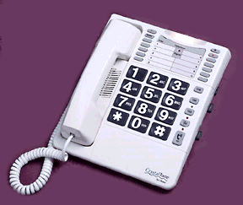Assistive Listening Systems:
Binoculars for the Ears

Amplified,
volume-controllable phone

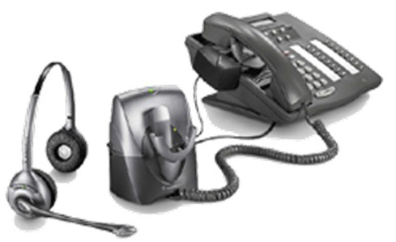Volume-controllable binaural (two-ear)
wireless headset

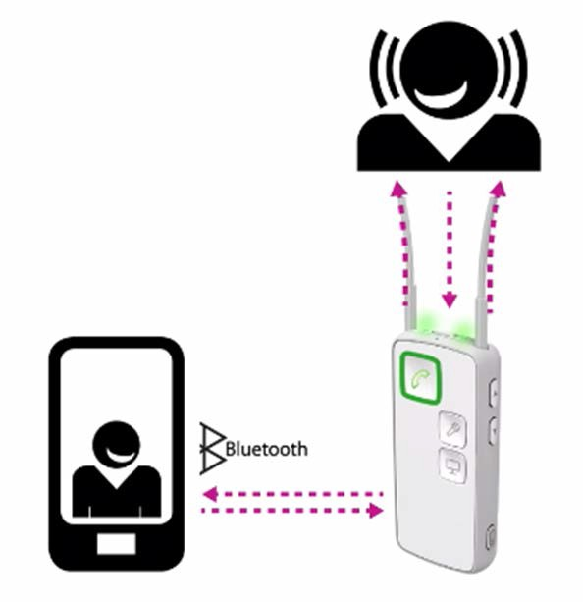Phone→streamer (via Bluetooth)→
hearing aids (via magnetic induction)

Demonstration: Call me!
616-990-0415

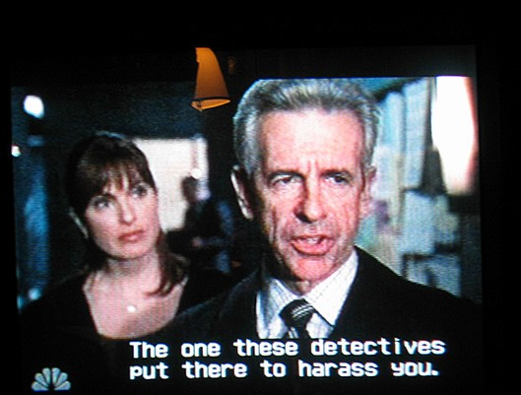Turn on TV captioning: The words sound
clearer when you know what they are!

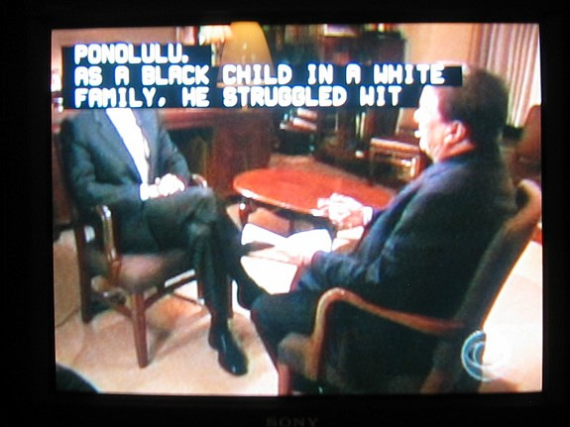

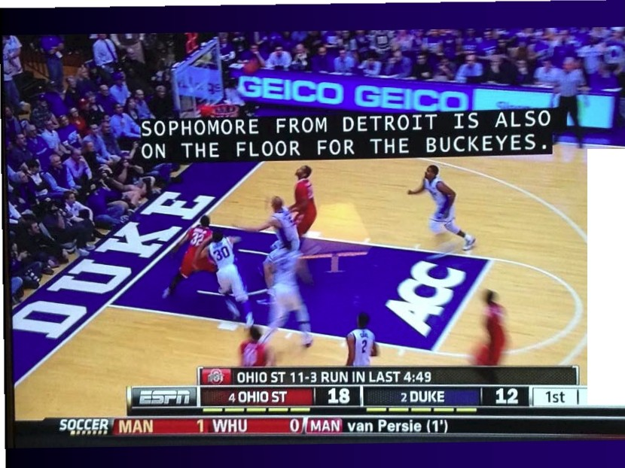

9 :2 7

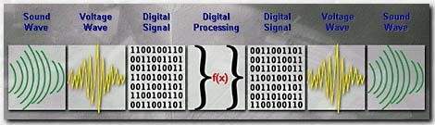

Digital Hearing Aids

- selective frequency amplification
- background noise suppression
- directionality
- sound compression
- telecoils

Sound Compression:

Too Loud

Too Soft

Sharon Sandbridge
The Cleveland Clinic Foundation

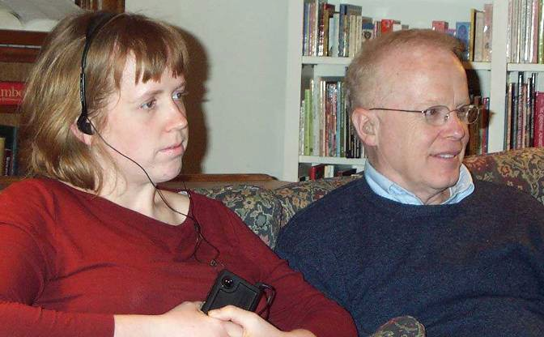Assistive Listening
- Prevalent in USA: hearing aid incompatible

Hearing Aid Incompatible
Systems Rarely Get Used

Muskegon Civic Auditorium
  - 1st use of assistive listening one year after installation

Holland Seven Theatre Complex
  - “once per month per theatre”

NATIO N I CHA NG E

Making
Change.
It's hard to
0Make It Clear
Studies suggest that better information­ about energy use,our diets, our mortgages, our credit cards-can help us make better
D Make It Easy
We are an Inertialspecies.We are much likelier to save for retirement or be organ donorsIf we are automatically s gned up to

get _people
choices. Public outreach and ce el>rity
do so as adefault and haveto take actiont<

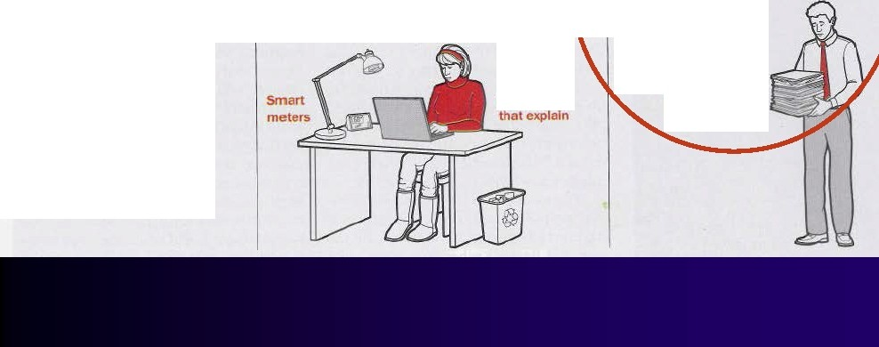to alter their behavior.But researchers say these
are the best
strategies
spokespeople can help;strict ru es requiring dis<:losure and darlty can he pmore.

Websites
opt out. We'lldo almost
anything-even things that are good for us-to avoid extra paperwor ..
k.
Too much paperwork !

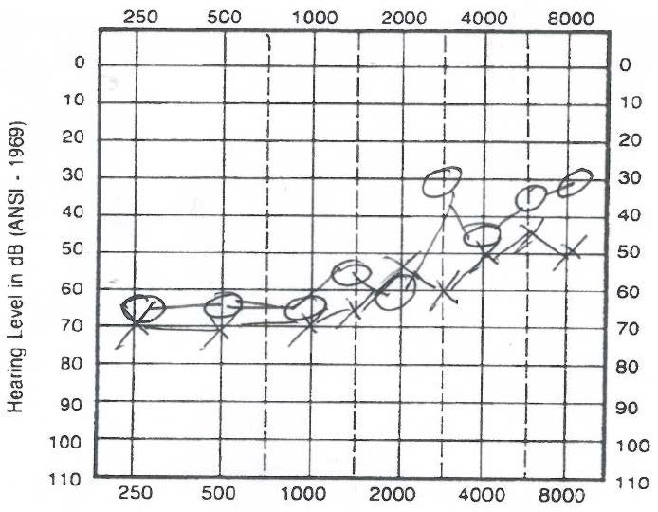Ideal assistive listening system:
customizing sound to one’s need

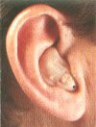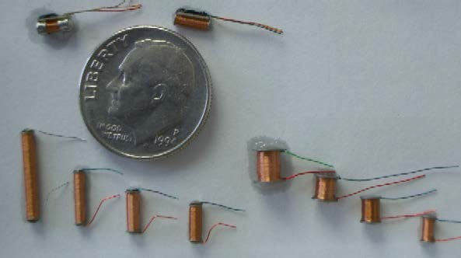

Telecoil (T-coil)

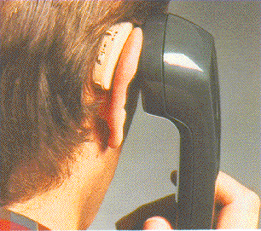

Landline phones (and increasingly cell phones) are “hearing aid” (T-coil) compatible

Cochlear implants are ready for induction loops

T-coil accessories

Cochlear ESPrit 3G with integrated T-coil
Advanced Bionics Auria
T-coil

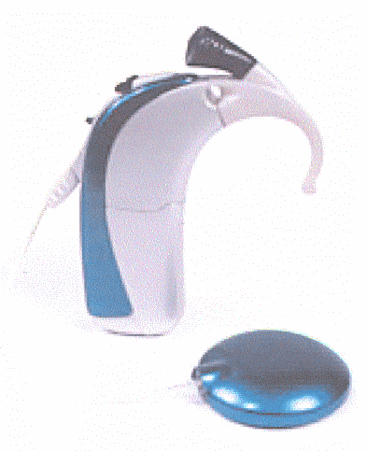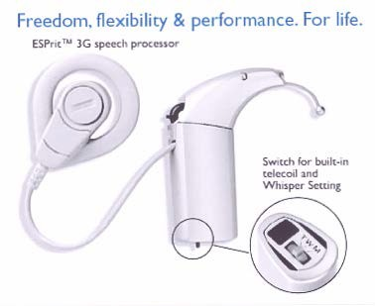

MED-EL
Tempo + TeleMic

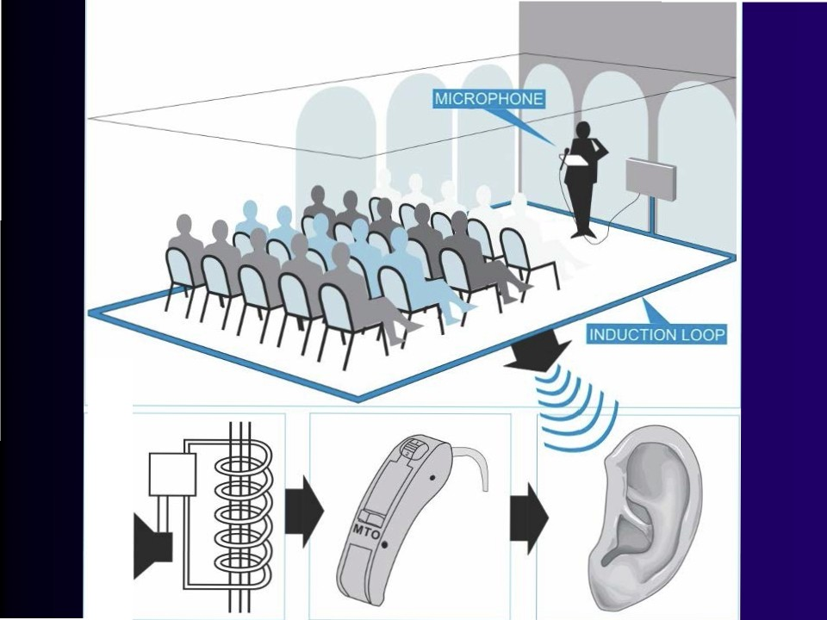

((@

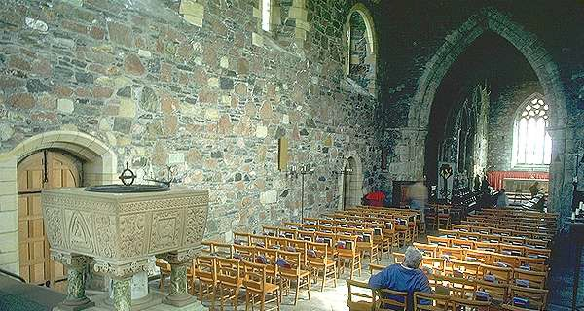

Iona Abbey, Scotland

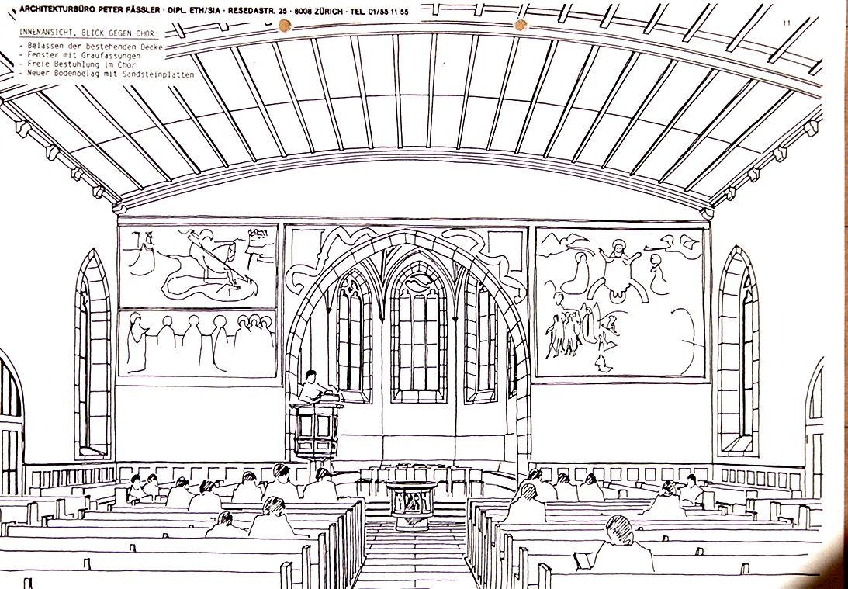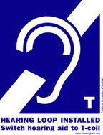

Reverberation and echos reduce speech intelligibility

Thanks to Siegfried Karg

In the UK (and Scandinavia)
hearing loops are everywhere

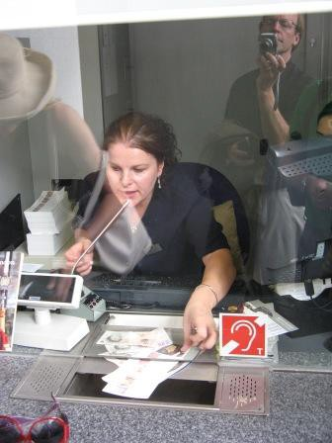

Tower of London

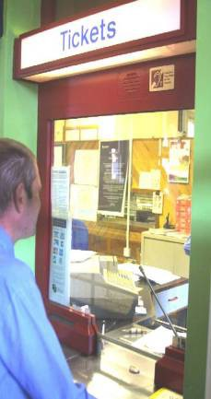

•

•

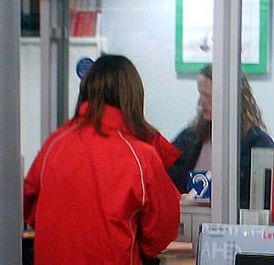Hearing loops now in 11,500 British
Postal Ltd. Branches(Guardian, 26 March 2009)

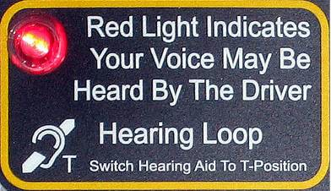

•

•

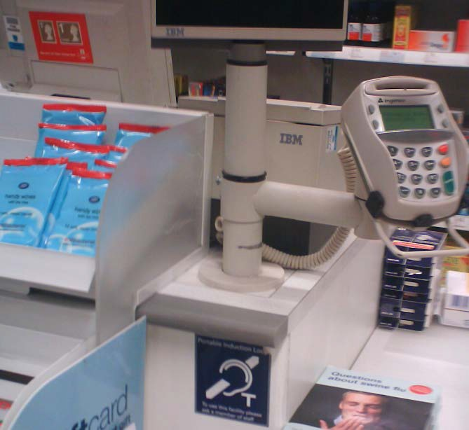

Boots (like Walgreens) Pharmacy Checkouts

Westminster Abbey

"The whole of the church is served by a hearing loop. Users should turn their hearing aid to the setting marked T."
~ The first sentence of Westminster Abbey's
program for the 50th anniversary celebration of the Queen's coronation, 2003.

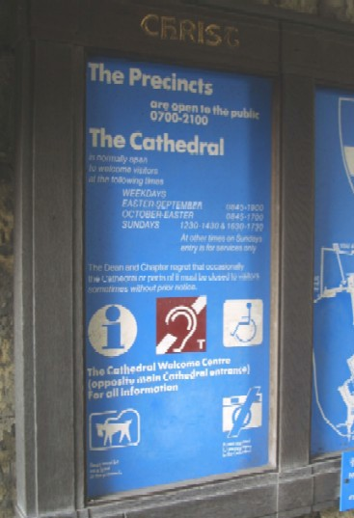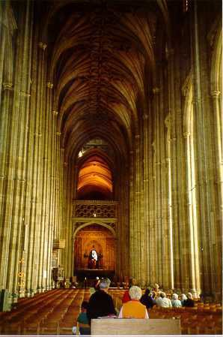Canterbury Cathedral

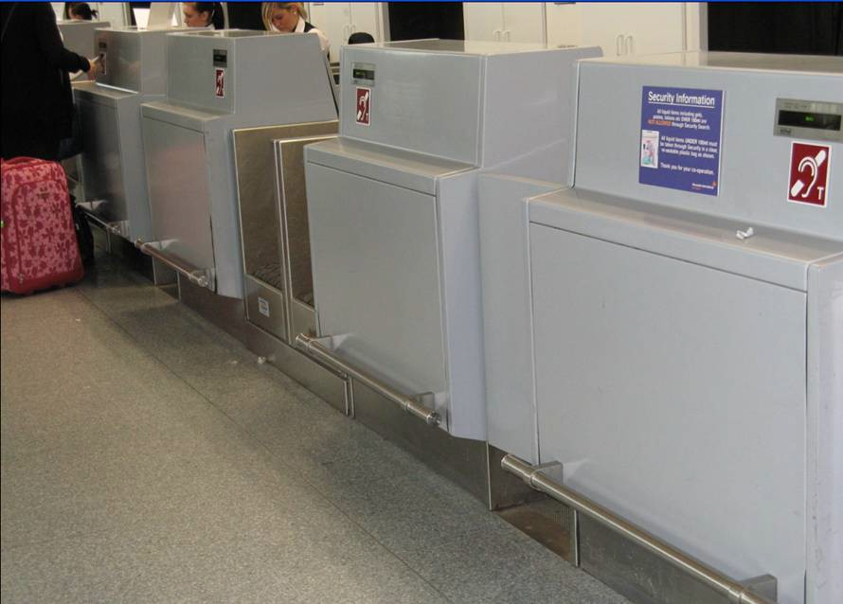

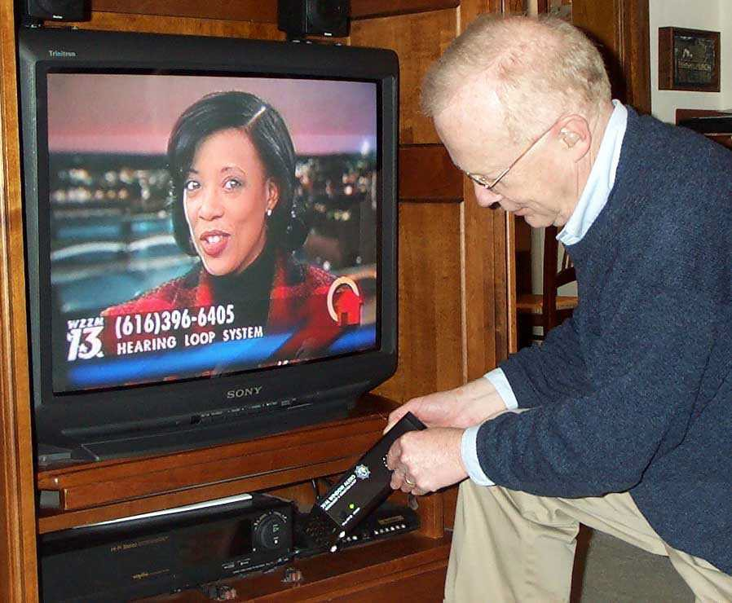

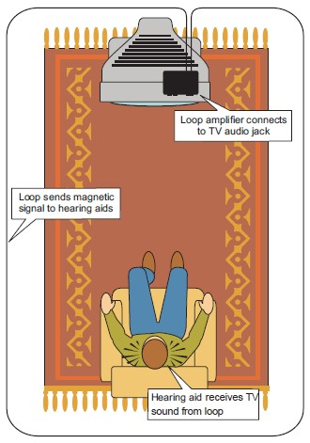

Percent of respondents
70
60
50
40
30
20
10
0
TV Satisfaction
(71 home loop users surveyed by audiologist Bill Diles)

TV w /o Loop TV w /Loop

1 2 3 4 5
Satisfaction Level (1 = low, 5 = high)

Percent of Respondents 60
Hearing Aid Satisfaction

50

40
HA w /o Loop
30
HA w /Loop
20

10

0
1 2 3 4 5
Satisfaction Level (1 = low , 5 = high)

From Sergei Kochkin, Juliette Sterkens et al., Hearing Review, October, 2014

45
n=866
40
35 Non-looped: Average = 4.9
Percent of respondents
30
25
20
15
10
5
0
Looped: Average = 8.7

1 2 3 4 5 6 7 8 9 10
1=“Heard nothing” 10=“Heard every word”

Looped situations Non-looped situations

78

www.HandsOnHearing.com

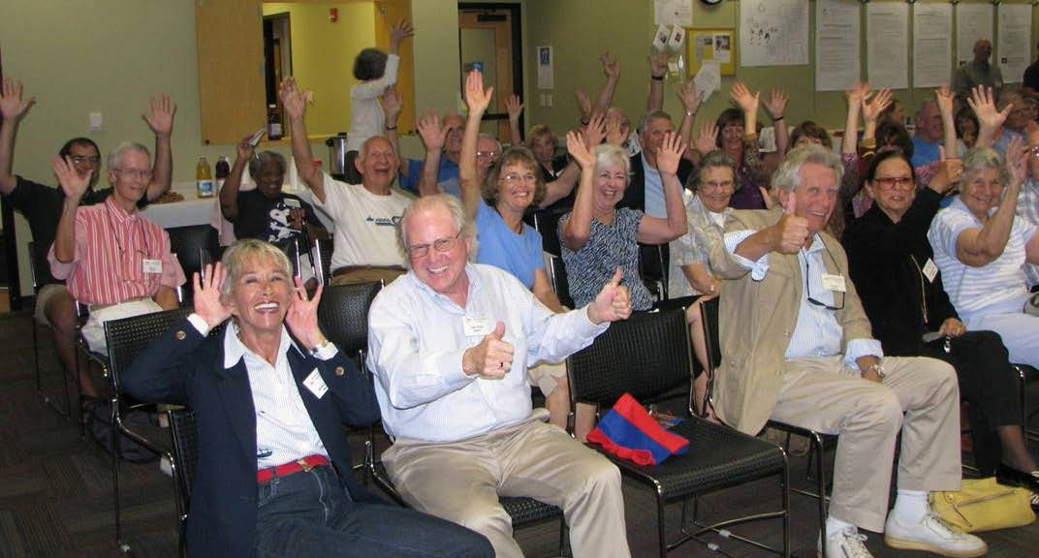Sarasota Hearing Loss Association members
when asked how they like their loop system

Courtesy Ed Ogiba

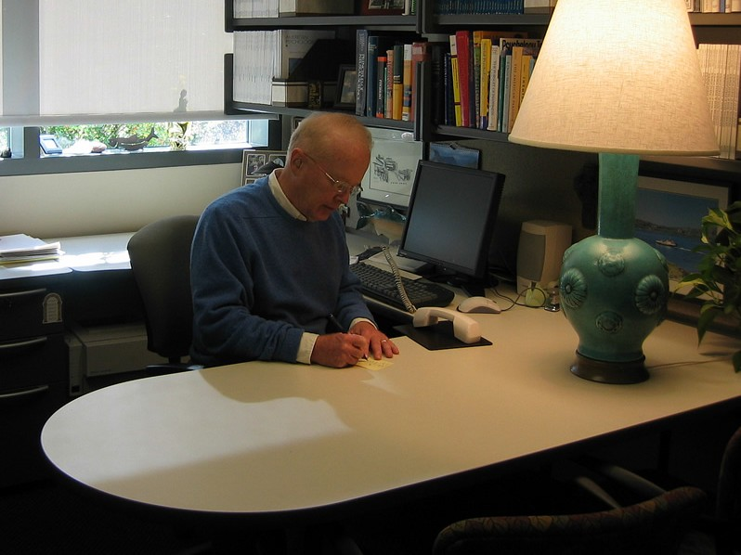

..,..,,,--

othing happens... but first a drea1n.

C A R L S A N D B U R G

People with he.aring loss can dream of a future when hearing aids might also serve as wireless loudspeakers,delivering clear, customized sound from inside their ears. They can dream of communities where worship places, auditoriums,business windows, and home lV rooms all broadcast their sound through these
in-the-ear loudspeakers. Thanks to the refinement of "induction loop"
systems--which magnetically transmit sound to hearing aids and cochlear implants with telecoils (T-coils)--that future can be now!

To experience hearing loop sound demonstrations and to see a child's reaction to a home lV room loop, click here.

For essays that explain and advocate for
hearing loops, see Scientific American,

An 1nduc:bon loop sym tninsmit:s magnetic energy to telec:o11-1..1pped heanng 111ds through 11 wire that surrounds an audiencr .

For a 2-minute animated explanation of hearing loops, see here, courtesy Otojoy.

For evidence about how people with hearing loss respond, see here.

2013 (here), and the Wall Street Journal, For instructions for installing a home

2015 (here for html and here for
printable PDF).
lV room loop, see here (PDF) or here
(video).

Questions about Hearing Loops

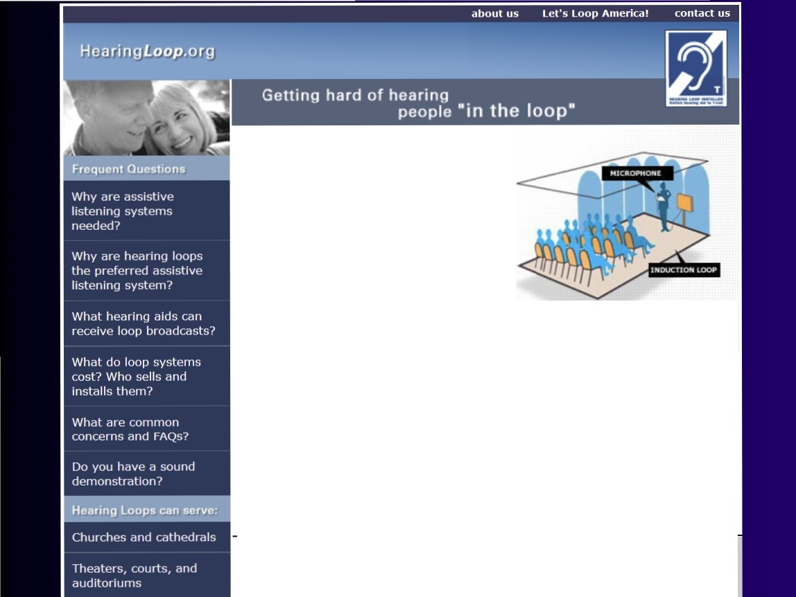llM'lat are common concerns and FAQs
::ihri11f lorin .c:v.<:fPm<:?
IW11at hearing aids have te/ecoils and can
f"Pf'Ai VP /(1()() hmArlf:A.<:f.<:?

i..;
•t

Aims of Local Initiative
- Aim #1: To make Holland-Zeeland (pop. 100,000) a model looped community
- Aim #2: To encourage other communities, regionally and nationally, to become looped

Pk'ffj pt WP'jNIP
c_""'"
...clhoo•
h'lt •• ,.,... ...."Nit...,
ht'°'•"" ac
"'•'o•
kt"'•"r "•-111•")
O!li1• CM1t.11\ .. O'l'fl•C
"4"'411 CNetc: Cl\.Mtie"1 ltef6"Med
...._lc..-.c•¢'w'••tr •11o llt•fo,."""
-. .,.......&•M>•t
.. ,."•-k ..
t. •t

ht....('ti(
c.v...,.,.
••=-t..•t
lltff • "'k It•'-"""
,-.-.d
;•t>o-'\•I

S...u ;•t..c
C6"1 ...

c.h ...., ••-.....c"""..."'
G.....,_ C
0c .....-. " •"-• «C
s.......11:•...,....
S...L'Olt.e !..-'\ lt•' :f
" • • C. a..LM Ol""*
R ,.

c ...,... 9*..,.:1t:'..
.• ...- ,Oe"f

'Ii
c;w-" c.--...... .,0..... ••
_..,.........,......,.....,....,...... ..........

(P!.-.1.t...'"..'...-.. ..e..1...c..........; ••
c.o.-.."t'M,,.""" t-, - · • e""""""'
C..•'Y"" ..... .,.'"
c::•••"6... c:;... ,..
c;.."°'•Cll C
°,."..'.-........."'.. · ·"'
1....-- ••
U">t.ff v o...._'"Ck 9't<\4 ., ,
  - l'I<! ......
"-••t•1'1\ n .. al s. ..,
z.C""•w ,....,
.

''tiot CAC
IQ• p(•UOftA\ f AQl1 1($

f l t"I llt• .,..,. 11
,,,L lM..t.etl .. .. {V. ()8..•I
"•''°'""'..
F-4'1°""'
FiPst A01"1d'et. Cl.C
t C!lt.C
,.,.,o.....,.,. ,.,"
,.. .t . ..'.".".'. •,i.•"..'..
,-,...t u..1t•4 "•t'-oC 1t
F•V"t••""'-"' sa.. t cite
C•l'l'I" c•.,..•
c.,1•-;•
•CeW.tt TM.t1!..i­
·0141'Cl\ •IM>i
•MA.JPd111>oo#ft
..... .,C.T"tt•r
..l'Mcl(,."'*"-...T"l••W
·"'••• .t.W'd to"'"""
c ......
•l'l."l•..111 ,
·S.C"I•• So. °"' ..u.....,.,, ......

f.l!l..."t"' lt••-..
G• •U""'C••...,•"'-" tt
'•""""4111••
...,1•"'4111 "" S O.J"i "'Q Nu Ct!
"'"'4.IM •""<'C "I kllloOf d11a• •••u
• $ ..-.... .\ltt C't!'

Ooo6 .. ._ ""'t,,.. ..
Qq ...""''•e•c
oa:..."'
Yi at•""' T S._,..,., •OM •
W

...t.e....·.c..1
"eac
.""_."""1to.....t.e.........
... ....._. ...... t1
c-.- ...1

!'' t C fWtmFS
' ...,.._.......... s........c -.t...
...... .......
.... .,. ,......, .t°"""'....

......
...""" "•"
"..'. 11 ,c_.. ...
.._."' C-..t "<l """ .......
...._."<! Cl'l.t•_..To-•"'

........... o.....c.. ...
•°'-'-... •• "IU c•c
.. i" "
.. ''"' C<ty ... ·c-- .....,.,.
.... ·u.o 'lltrt C.."lk·
ty$1tUsus eep 1ose1Y'ft'''!

.l..ee<••I.t.•..'.. ,...,.."..
S......t" "' •"'

.11\ ....\..iM' · ..._."""', ..
""'-''...

i....a.:............•.•"•o'wt
"•,."'• "'•cc
""'•"'-cc
'•o.tt-"t!'•...,40c"'1cCltC
cz....., .,,,.."l..U•\•h,. ........ ... .,
''••M-n"""'•w• reti,...,.....,,_ <,.,.,..,)
\....toe....•......,_•-""•(l•llloll"> ftod Alte.; ..'
Ctrt f 2 lec1t!o.,••
"'•c•t•

••11•"14 - •.,.,,••
    - A\ aiif e DiT
k'I< (t.e<t•,....
''• >

W\."I
c-.'\t .lJ """'" o' OH
t....,
i c--.c
•.,..,19'"\•,..ttr .W •1t111)9'fe Df )

Cal.di CtlC M,.,..,,..,.J
tr.oti- .. of ... •.,,; !•"Id "....,...

,, ,.. ..... rr. ... ou ...
•""'•"
0'."a.."'-" $ T1V1t d"'• t.. a.J

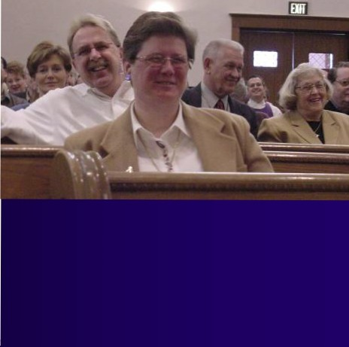Oo...."...' '•I,C..fl:C
c
o..,..,. •t·.., c. c.....t ..
...a..".. <.....,_ e'f't.' : .."""'"'* , ..t..)
...
---'-"c'•"U J,_.,,.,-aJ ------

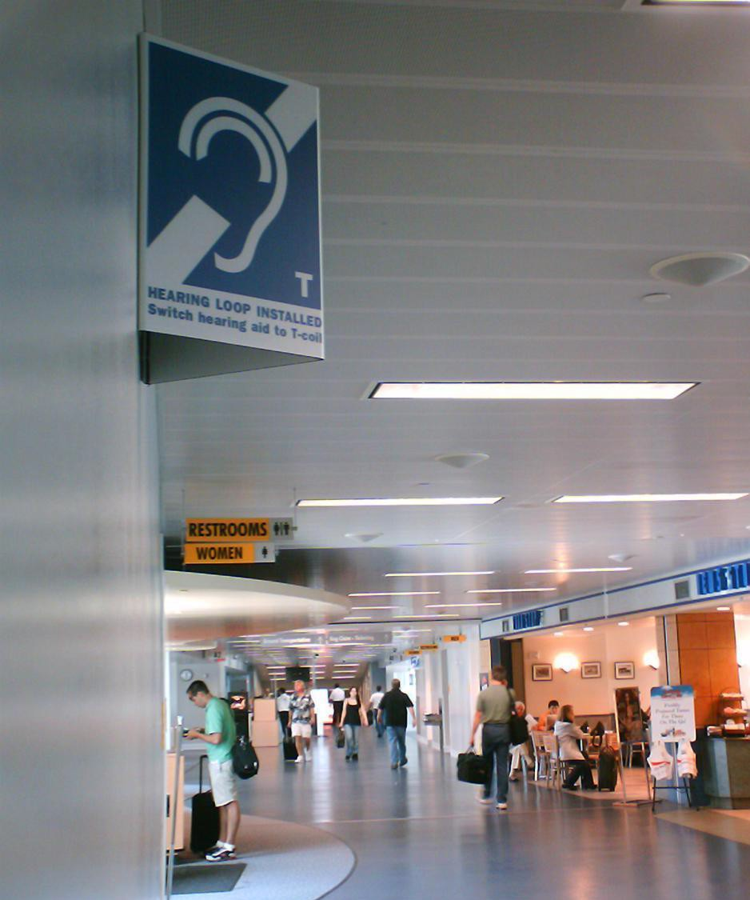

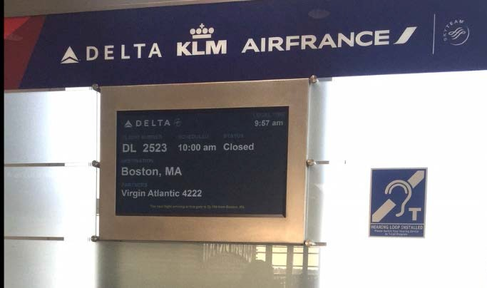

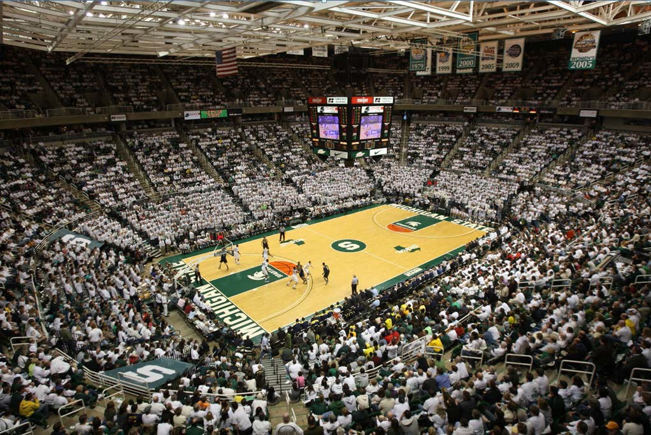

Michigan State University’s Breslin Center (12,200 of 14,759 seats)
Courtesy MSU Sports Information Department

•

1n
•

ear1n
A Joint Project of t11e
__. ... Heari11g Lo A, ocia.tion
of America and tl1e Anierica r1 Acade1ny of Audiology

Initiatives underway in

Wisconsin
- Illinois
- Arizona
- New Mexico
- Silicon Valley
- New York City
- Florida
- Oregon
- Seattle

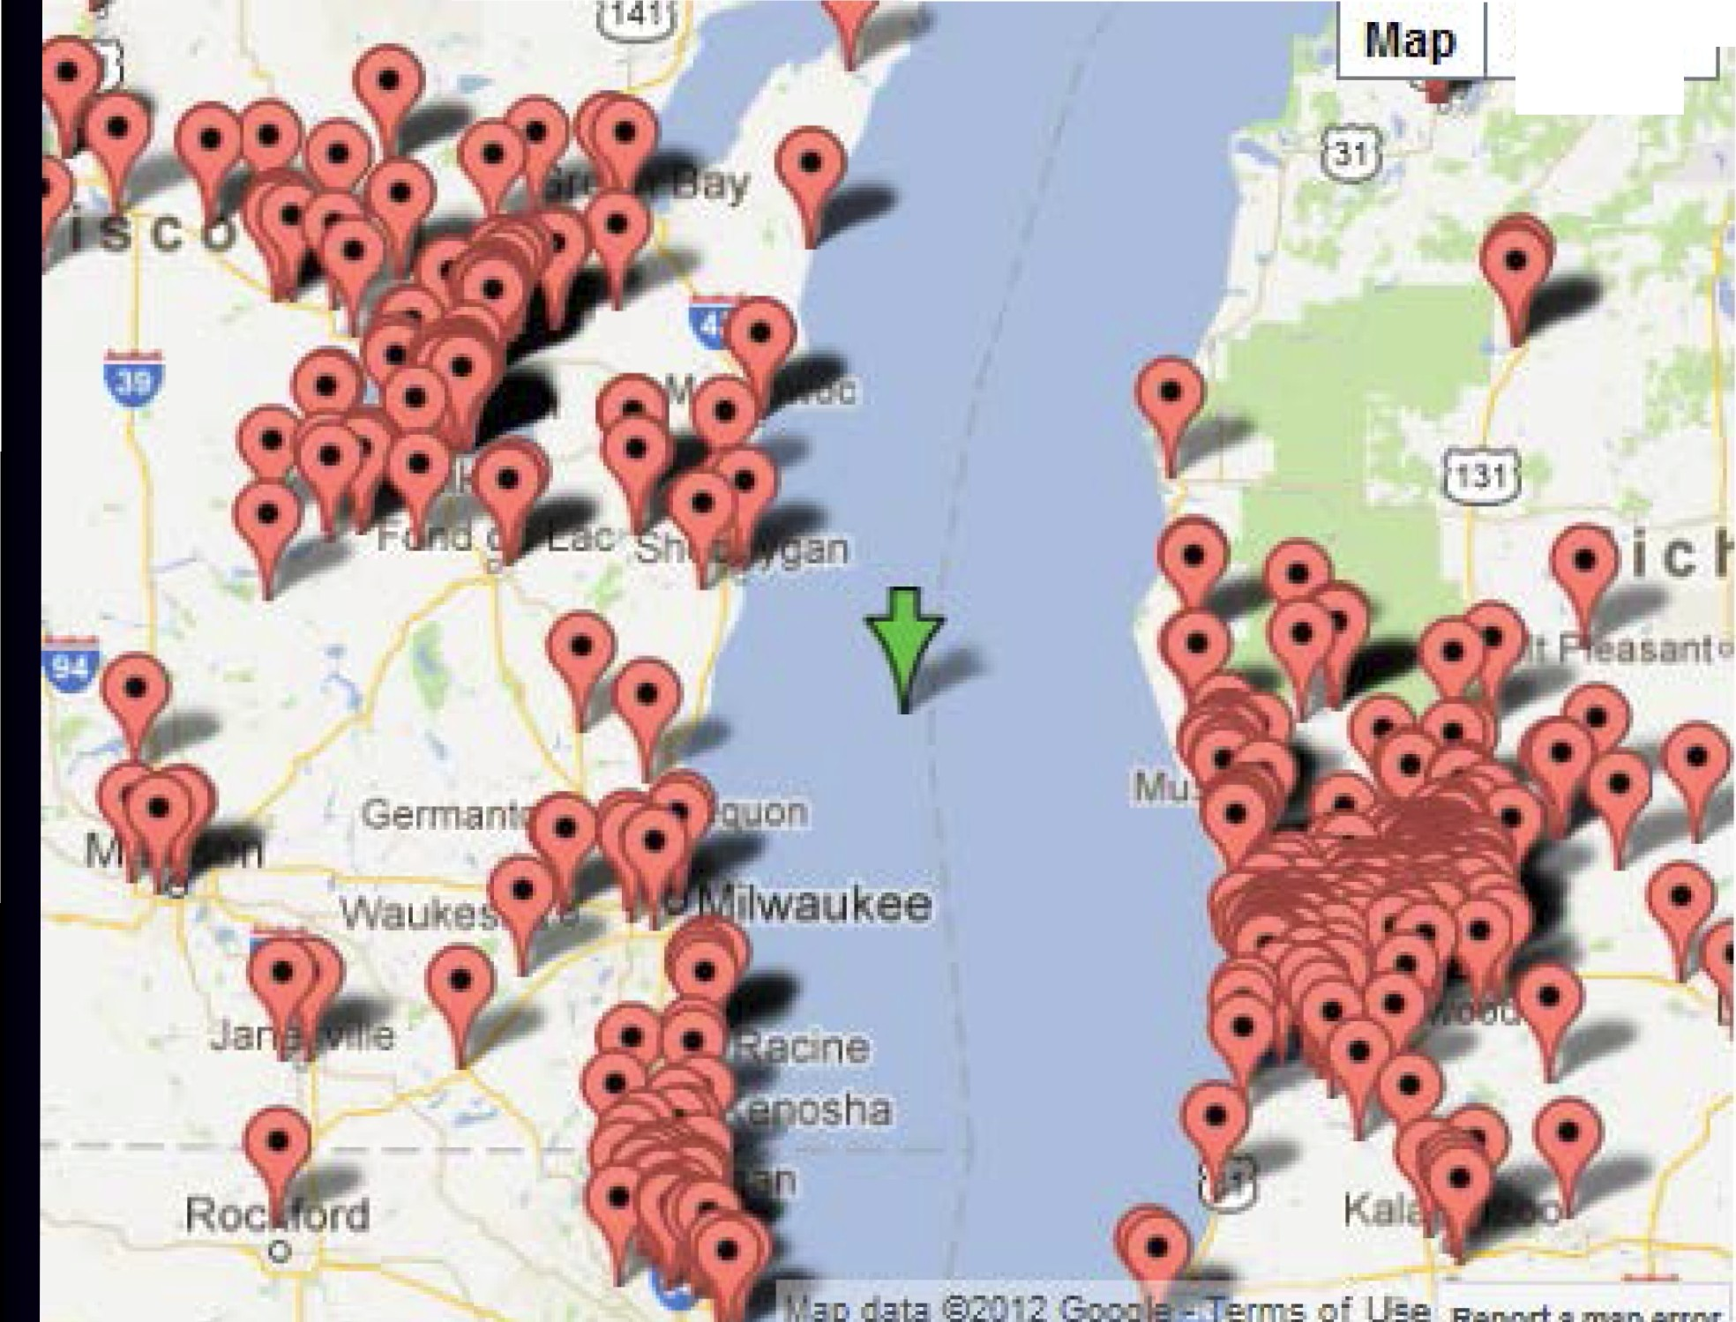Satellite

-.-.

-.....-

...·-

.....
1...,
I..l.l..
... -

.--..-. ------··.--.---_---..-·.
l
-....
".".".".'
---

-·---11111o
... .......
-.....·-·-..·--..-.-.·

.. .-..··

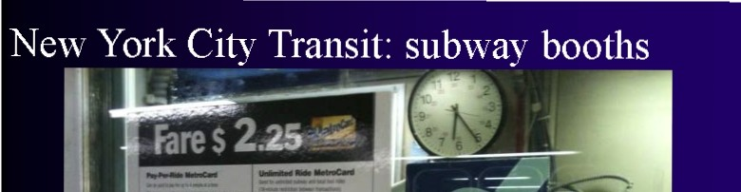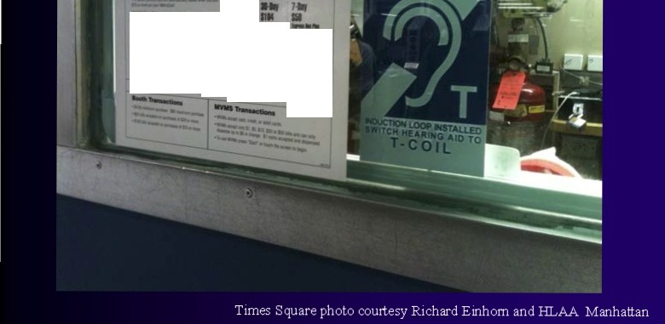"'-
................._ --··-----·-

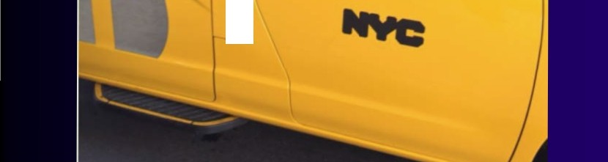

I .,......
.....,-.,.....,
)

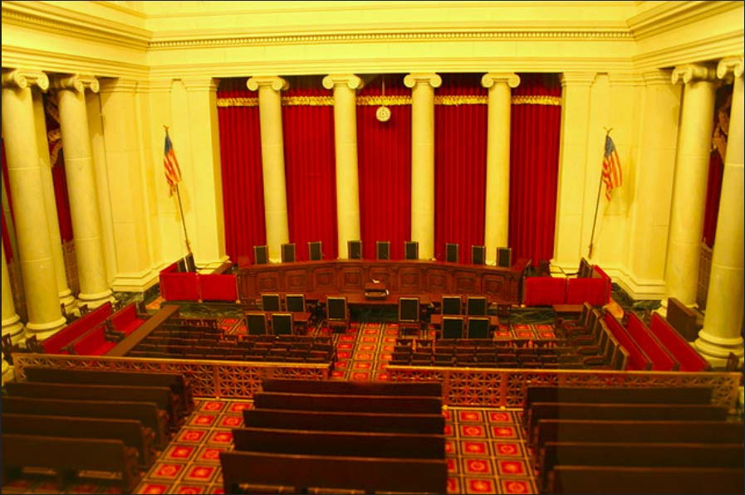U.S. Supreme Court Chambers

Likely new mandate: Hearing
accessibility (via loops) in U.S. rail and subway cars

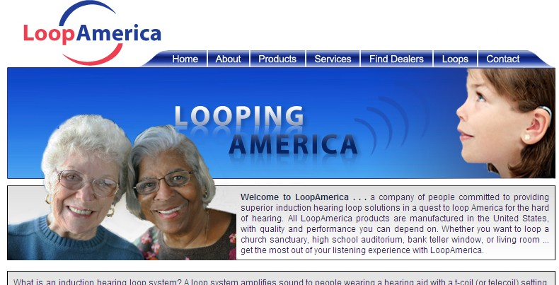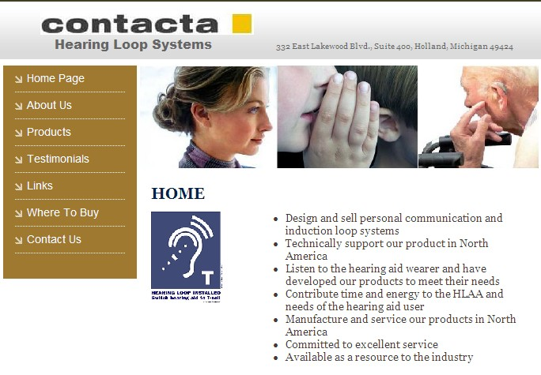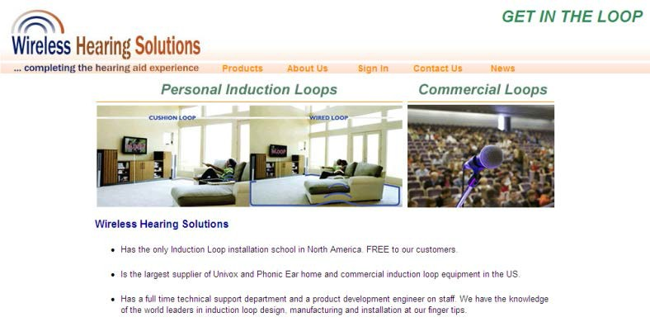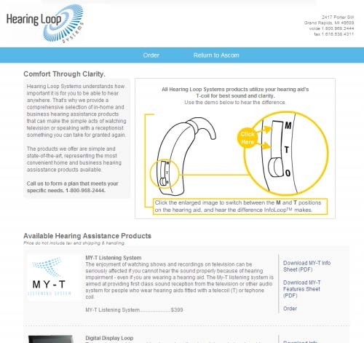New Companies

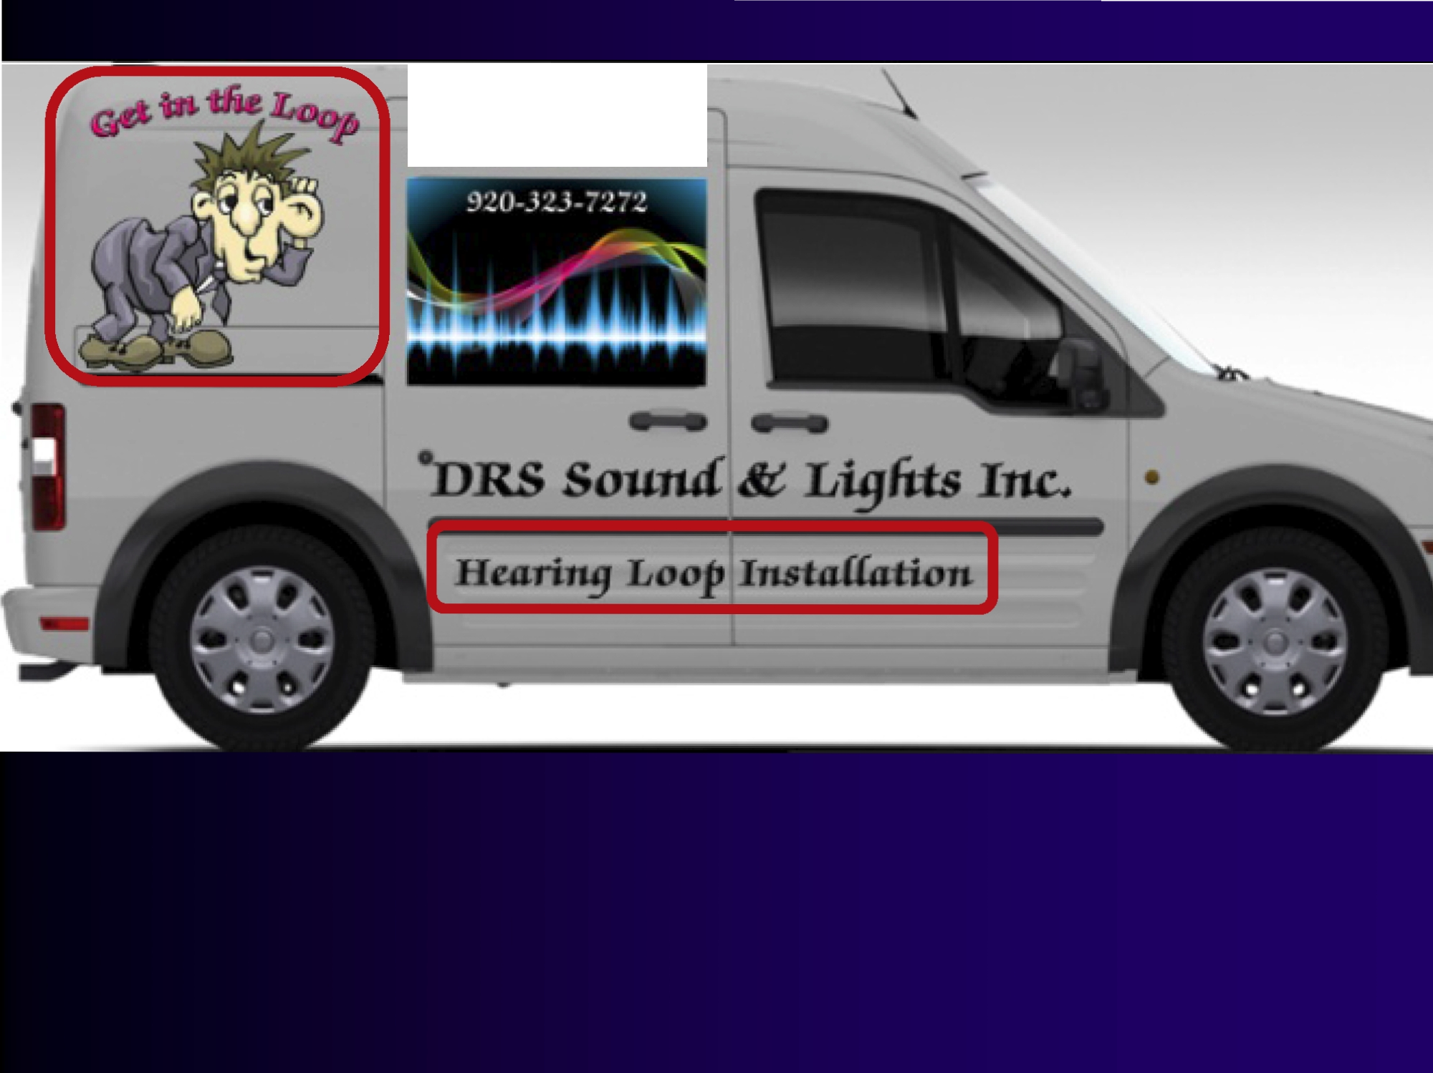
www.4rs1oun4.com

HEARING CHAR ITIES
0
F
A
M
E
R
I
C
A
Community • Con1munica tions • Commitmen t

National Action Campaign Summary

A "Sound"Investment
A campaign for equal access

The Goal
To make the sounds through public address and amplified systems in public facilities
rea · · · vices. We can achieve this goal by romoting and assisting ininstalling looping technolo public buildings and facilities.
This e · · e available, but will promote the
value ar1u irupurla.lll:e uf hearing 111::<tllh :servil:e:s i::tilU lel:bnulugy .

Breaking New.11, Since 1847

Travel Health Opi nion Real Estate Cars Jobs

Fiitness Diet & Nutrition Investigations & Data Live chats HeallthKey

Churches putting hearing-impaired in the loop
More than ,a do1zen area houses of wo1rship install ma.gnetic system so1 all can listen to Scripture, sermon, service

JUJ ly 02,201O I By Manya A Brachear, Tribune reporter
IIRecommend 14 B ··
3
Submit +1

For about four years. the Rev_ Christine Chakoian recalls hearing nothing but gibberish when members of her north suburban Presbyterian church rose to ask the congregation to pray for them on Sunday_
Cut off by a combination of the sanctuary's acoustic s and a typical hearing aid that blurred soun1ds traveling a 1distance. Chalkoian wouldr11't know what to pray becaU1se she couldn't understand what was said from the pews.

BUII EllN

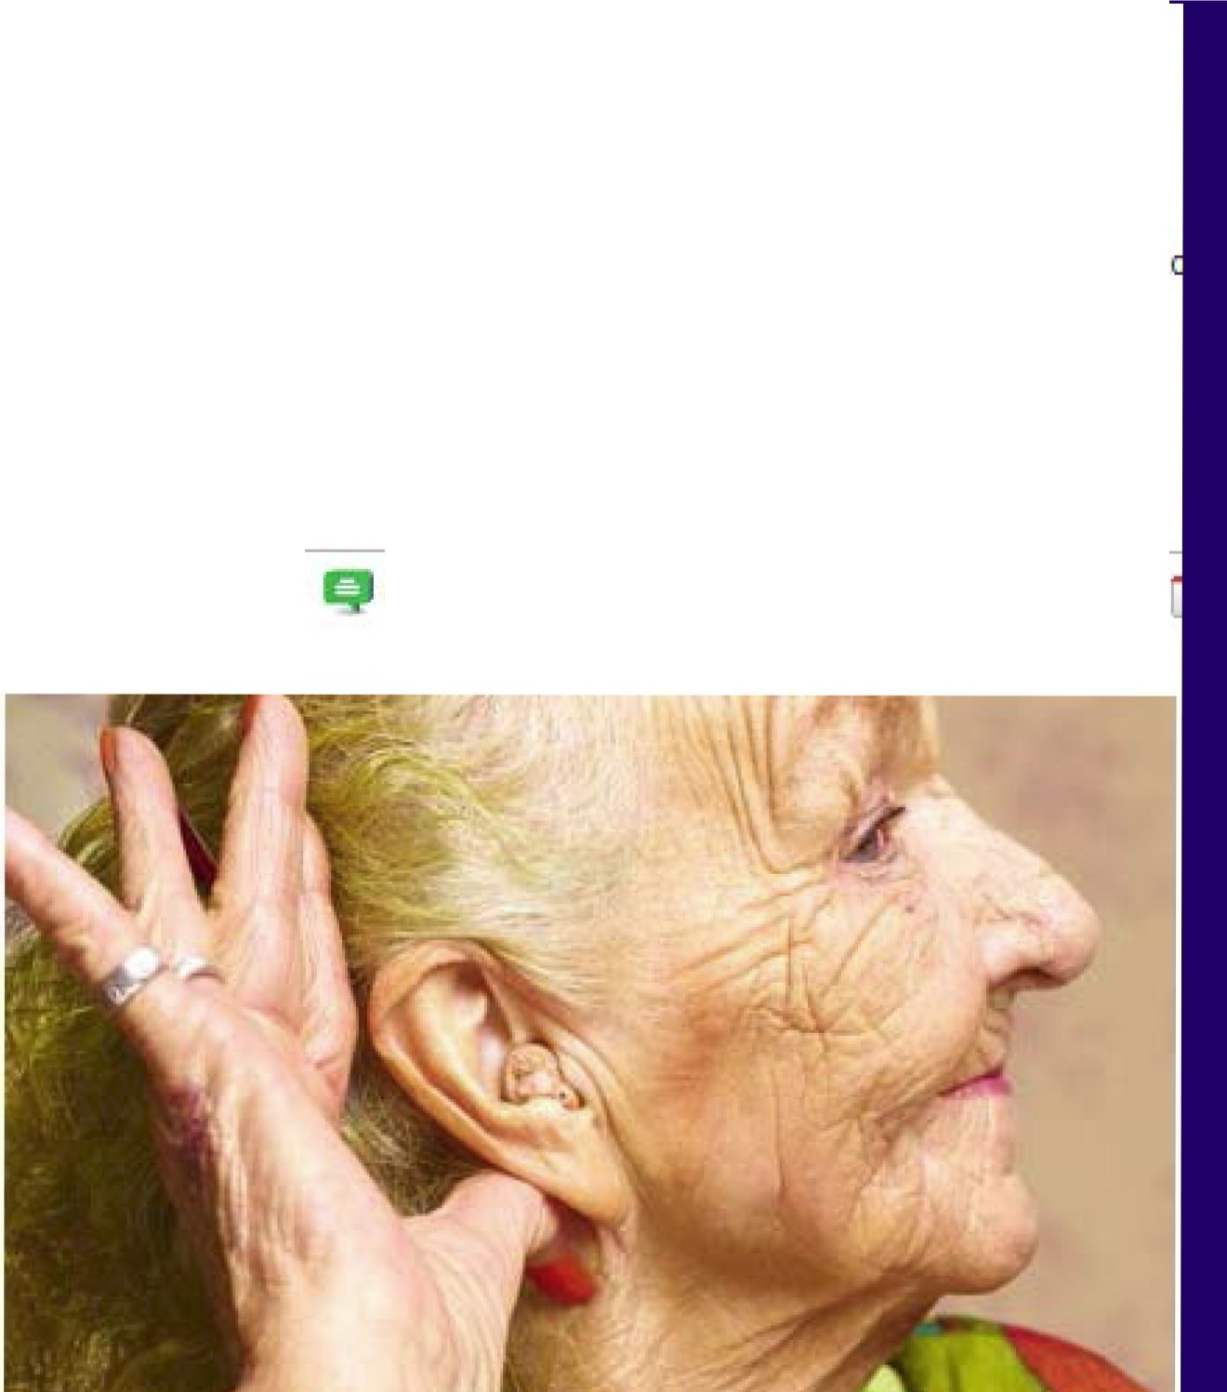MEMBER BENEFITS

Conditions & Treatments Health care Reform
Insurance & Medicare Healthy Living Longevity
Brain Health Doctors & Hospitals caregMng
Drugs & Supplements
Experts
Health Tools Health Products
MONEY
WORK & REllREMENT PERSONAL GROWlH POUllCS & SOCIElY

HOME & GARDEN
.A.ARP Home » Health >> Conditions & Treatments » Hearing Aids in the L

Heal tl1Discovery
Hearing Aids in the Loop
by. Cathie Gandel Ifrom:AA.RP Bulletin IJune 22 , 201o

Text I ,.:_ Print I Ca mments (20 ) I Email I Recommend (249) I

*E VE RY DAY I S
SCIENCE FRIDAY

YOUR
HOST
IRA
FLATOW
Support Science Friday
Ciiek He• To
Become a Sponsor
••
Makea Donation

Home isten f Podcast
Biogs Video SciArts Spa nish f TalkingScience About Log in I

Search!

listen:
, ..,

download mo3·)la!

1 •"-ol I
Friday,July 2nd,2010
Loop Hearing

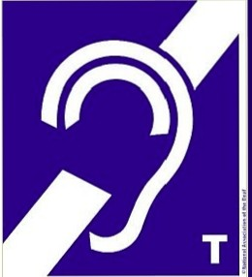mloodcast Cwhars!hjs?J
-> Friday,July 2nd,2010 Loop Hearing
Summer Science:Ben Franklino(
Sun ActMty o( • Centenarian Genes <
Got Ga ic? The Science of Alliyms o(
Summer Sky Forecast <

I : Elsewhere on Sciencefriday.com
Cell Phone Radjalion
...t(.... Affects Brain Stydy
SCIENCE Says -C
l-'i:R!.8 Y.
·h;llllOi'o'
I -...
l_,,IWhat Does '4G' Really
.-IMean Anvway? -Cl
S l NE-
The hearingloopis anassistive technology for the hard of
heanng tharspopularinEurope,butless widespreadinthe US. Think of itlike wireless networ1<ing for hearing aids.The technology uses aninductiveloop to transmitsound signals
diredlyInto anIn-ear hearing aid or cochlearimptan where it 1s received by aninductive de\'ice called a elecoil.Proponents of the system say it works especially wellin public places with baekground noise,such as train stations or places of worship, as announcements can be transmitted directly to the ear rather than being picked up by an external microphone. The approach also does not require the use of bulky receivers or headsets,as many asslstive hearing devices commonly used in the US do. It does, however,require that the listener have a hearing aid equipped with a telecoil for reception. We'lltalk about the technology, and why it hasn1been embraced in this country.
IJ c lJ
Guests
David Myers

HEARING LOOP INSTALLED
Switch hearing aid to T coll
..,, ,.Nlf'll"lloQp ...q

S HO P

MA RC.JA C O BS.C O M

Sv1itch to
Global Edition • Panetta's
JOSS Pentagon,

Monday, October 24,2011 Last Update:10:11AM ET
ISe8'ch I Follow Us IJ
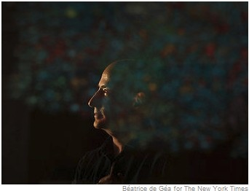OPINION •
EDITORIAL
No Holiday

REAL ESTATE Without the
AUTOS
All CLASSIFIEDS Blank Check
WORLD By PETER BAKER
U.S. Leon E. Panetta, the new POLmcs defense secretary, must NEW YORK balance military cuts BUSINESS against a spectrum of DE.Al.BOOK national security threats.
TECHNOLOGY • U.S.to Keep Presencein SPORTS Pacific,Panetta Says SCIEJ'.<CE Iii Post a Comment IRead (41)
HEALTH European Leaders OPINION Deal Directly With ARTS
Books Debt Dilemma
By STEVEN ERLANGER and

A Hearing Aid That Cuts Out All the Clatter
By JOHN TIERNEY
As more hearing loopsare installed in public spaces,
A tax holiday wouldbe a
windfall for major corporations at the expense of everyone else, and it would raise the deficit.
·Iiicomment

·Krugman: The Hole in Europe's Bucket
·Editorial:'\Vhat Kind of
Government?
·Op-Ed:Seven Billion The Stone:International Adoption
·Note to Readers

ldovies
STEPHENCASTLE
people who have felt excluded, like the composer Richard

ldusic Leadershope the seriousness
Television
Theater of their effort to solve the
STYLE problems of Greek debt,
Dining & Wine weakbanks and abailout
Fashion & Style fund in need of
Einhorn, aoove, are suddenl y back in the conversation.
·Iii Post a C1>mment IRead (27)
-- Comparing Subv1ay Sounds
8 O:SO _,.

l\•IA.RKETS » At 10:25 AM ET
S.&P. 500 Dow tlasdaq
1,248.46 11,882.13 2,670.88
+10.21 +73.34 +33.42
+0.82% +0.62% +1.27%

articles in the
480
' · past mont h

Most Emailed GO TO: Most Viewed I Most Blogged I Most Searched I Most Popular Movies Articles most frequently e-mailed by NYTimes.com readers.

LAST 24 HOURS LAST 7 OAYS LAST 30 DAY S UPDATED EVERY 15 rdlNUTES

- New iPhone Conceals Sheer Ivlagic
By DAV ID PCGUE
The iPhon1e 4Sis Joaded ,.,.r]th dazzlers :faster speed, a camer a that es crisper shots, global reach and transformativ1evoice recognition.
Go to Article I E-Mail
2. .!.\.Hearing .4. id That Cuts Out .4. 11 the Clatter
By JOHN TIERNEY
As bearing ]oops are instaJ]edl in stores, banks,museums , subl1'fay stations and other pub]ic spaces, peop],e wh o havefeJt 1exclodedl are sudden]y back in the conversation.
Go to .A.rticle I E-Mail

THE WALL STREET JOURNAL.
Home World U.S. Politics Economy Business Tech Markets Opinion Arts Life Real E

REV IEW & OUTLOOK
........,
r \ REVIEW & OUTLOOK

REVIEW & OUTLOOK

BEST OF THE W

.,. Obama Takes the Military Hostage
(0, ;i127 .,.Acting Up
l .pf1d Against the
!Js9'3 < Minimum Wage
.,.Trump's 9/11 Truthing
.,. Could lt Here?

YOU ARE READING A PREVIEW OF A PAID ARTICLE.
SUBSCRIBE NOW
TO GET MORE GI

OPINION I COMMENTARY
A Technological Godsend to Counter Hearing Loss
The 'hearing loop' is a remarkable advance, but all too hard to find in the U.S.

By DAVID G. MYERS
Updated Aug.27,2015 7:24 p.m.ET

30 COMMENTS

The first time I clicked on my hearing aids' telecoils, it seemed like magic. Itwas 1999 and my wife and I were sitting in a historic abbey on Scotland's Isle of Iona. I had gradually

The Social Psychology of the
Hearing Loop Movement

Persuasion
  - Message repetition
  - Vivid story telling and demonstrations
  - Credible communicators (HLAA, AAA)
  - Influential models

Social networking (the pack > the wolf)
- Media influence
  - Persistence: “You don’t get pellets unless you bar press”

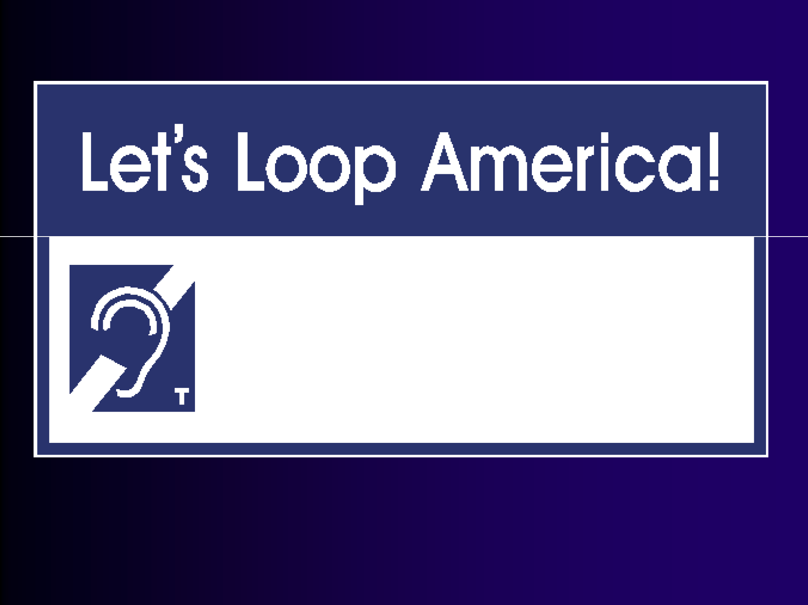

hearingloop.org

A
f2!! iet
World
Living with Hearing Loss

For further information . . .

DavidMyers.org HearingLoop.org

