Spirituality in the Context of
Non-verbal Autism

Karenne Hills

1

2
Introduction

• Each individual with autism is unique

• WHO global stats estimate 1/160 or 1% world
pop (Lai et al., 2014)

• U.S. stats approximate 1/68

• Many have exceptional gifts in visual skills,
music or academia

• Approx. 60% have no intellectual impairment

• Approx. 25% are non-verbal

• Communication can be successful via assisted
communication

3
Introduction

• The incidence and relevance of autism is increasing

• Those with most severe form a significantly
under researched group

• Communication and relational barriers

• Humanness of these people must not be
ignored

• Spirituality an essential element of humanness therefore worthy of exploration

• Thus…..Spirituality in the Context of Non-verbal
Autism 4
Background

5
Background

• Topic birthed from my own life story

• Life brought the opportunity to ponder difficult questions

• Convinced of an intentional design rather than a
random mistake

• Societal attitudes create a perspective of less than perfect – Dominant understanding (Clapton, 2008)

• Needed to expand my mind

6
Ponderings

• If divine inspiration does provide purpose and meaning to the life of someone living with a disability, then how does such a person experience their own connection to the Divine?

• Does the inability to express such an
experience negate its existence?

• If people with profound disabilities have a unique spirituality, can the experience alone
lead towards deeper divine connection?

7
Guiding Purpose

• Built on interwoven framework of theology
and spirituality

• Life brought the opportunity to test hypothesis

• Andrew is introduced to Jesus and something changes

• Whatever happened with this young man
somehow impacted me

8
Autism Defined

• Complex neurodevelopmental disorder

• Spectrum disorder with large variations in severity and expressions

• Increasing at an alarming rate – approximately
1% of population worldwide

• Australian statistics: 2009 – 64,400

• 2012 – 115,400 (79%

increase)

• Characterised by idiopathic symptoms in skills used for socialisation and communication
9
Autism Defined Con’t.

• One end of spectrum – Asperger Syndrome -
verbally competent with social challenges

• Severe end of spectrum – Non-verbal autism - limited social engagement and little or no verbal language

• Often assumed unintelligent and unfeeling

• Extremely sensitive, higher intelligence

• Sensitivity to noise and atmospheric changes,
more spiritually aware (Stillman, 2003, 2006)

10
Non-verbal Autism

• Absence of verbal language - Insurmountable
challenges

• World revolves around language

• No language assumes no intelligence

• Largely misunderstood group

• Almost all research to date focused on
innovations to develop verbal speech

• Changes slowly seen with FC/AC

• Researchers – Stillman, Grandin, Pasco, Eagle, Whittaker
11
Non-verbal Autism
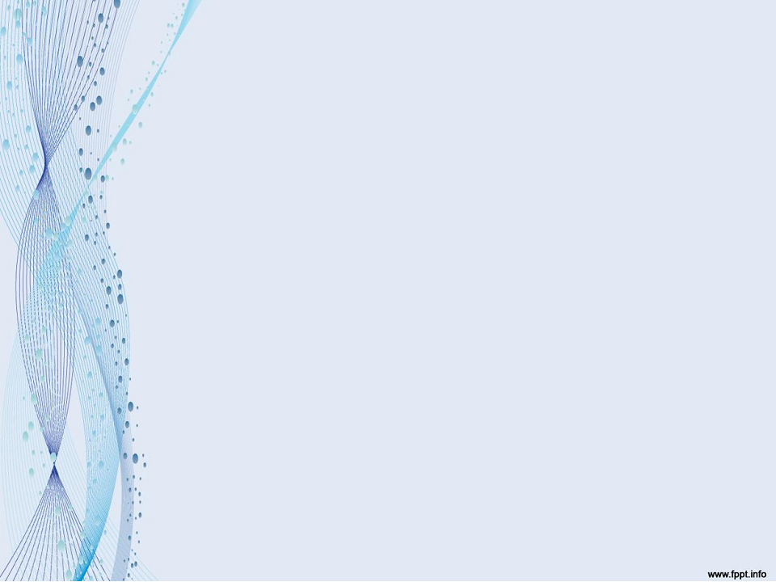

• Cause unknown

• Many hypotheses but cause basically a mystery

• Therefore, differing definitions with no one clear factual account

• Understood to mean the lack of “sufficient natural speech to meet their daily communication needs” (De Leo & Leroy 2008)

• “nonverbal intelligence and social engagement”
found to be predictors of speech (Wodka, 2013)

12
Theology and Spirituality

Defined

• Theology - The discipline supports knowledge, understanding of God

• Explores how humans may relate to this Being

• Disability Theology an emerging empirical
discipline

• A different way of looking at God and humanness (Swinton, 2002)

• Opportunity for sound theological pursuit

13
Spirituality Defined

• A fluid process – deeply personal (McSherry,
1998; Swinton, 2002)

• Better described than defined (Adams, 2009)

• A lived reality (Chan, 1998) providing meaning and value (Muldoon & King, 1995) transformation and discovery of self (McIntosh, 1998)

• Primarily about lived human experience

• Inherently oriented towards discovery

• The place where humanity meets the Divine

• Spirituality and Theology intimately related
(McIntosh, 1998) 14
Disability Theology

• Within Christian context a rapidly growing discipline

• Suggests implications not only for faith
communities - Other organisations

• Intentional effort is required to create a meaningful space for people with different abilities to express their spirituality

• Space for unique spirituality

15
Disability Theology Con’t.

• Statistically, people with disabilities absent from society

• Especially true of faith communities

• Modern society struggles to engage with the
narrative of those with a diminished voice

• Disability Theology affirms they have a gift to give to individuals, organisations and society as a whole

16
Research Aims

• To come from a place of genuine
enquiry

• Request to be invited into the world
of the person with non-verbal autism, rather than to invite them into my world assuming it to be better

17
Research Questions

–1. What are the spiritual experiences of people
with non-verbal autism?

–2. What can be learned from the spiritual
experiences of people with non-verbal autism?

–3. What are the implications of the findings of this research for faith communities and other service providers?

–4. What should be the direction of further research on the spiritual experiences and expressions of people with non-verbal autism?

18
Methodology

• Starting Point – Scoping literature review

BECAUSE

• Difficult to conduct qualitative research on people with non-verbal autism due to obvious communication barriers

• Lack of clinical trials involving non-verbal individuals means that an alternative systematic literature based methodology such as a meta-analysis was not possible

19
Five Phases of Literature

Searches

• Phase | 1 | – | Theology of Disability
• Phase | 2 | - | Theology and Spirituality
• Phase | 3 | - | Spirituality of Disability
• Phase | 4 | – | Alternate Literature
• Phase | 5 | – | Social Multimedia

20
Phase 1–Theology of

Disability

• To discover about people with non-verbal
autism from a Theological viewpoint

• Current attitudes and beliefs within faith communities about disability, particularly non-verbal autism

21
Phase 1 - Themes

• Disability theologians and faith communities struggle with the same ethical and organisational responses concerning social attitudes of equality and inclusion:
• Overcoming barriers to inclusion

• Faith used as a coping mechanism

• What the general faith community may learn from people with
disability

• The value of the dependent/interdependent relationship

• The integration of programs designed for people with disability

• Modified curriculum for scripture lessons

22
Phase 1 - Research Gaps

• Research Gaps

• Little research exploring integration and inclusion for people with autism

• Unique barriers for non-verbal people

• An opportunity for autism as a specific criteria within
Disability Theology

• Limited research on unique spiritual experiences or expressions for people with disabilities, particularly autistic people

• NO literature concerning the theology or spirituality of non-verbal people from their perspective

23
Phase 2 – Theology and

Spirituality

• To determine difference between theology
and spirituality

• To explore Theology of Spirituality

• Silence and contemplation

• Mysticism

24
Phase 2 - Themes

• Working definitions - theology and spirituality

• Difference between theology and spirituality

• Exploration of process and experience gained by
spiritual discipline of silence and solitude

• Silence and solitude have been used as a means to draw nearer to the Divine in history of every world religion and indigenous people group

• Bias observed in consideration that the spiritual discipline of silence elevates one’s spiritual status, however those whose life context is silent by design not choice are devalued

25
Phase 3 - Spirituality of

Disability

• Spiritual experiences of people with
disability

• Focus on autism, particularly non-verbal autism

26
Phase 3 -Themes

• Friendship central to spirituality

• Cognitive and developmental capability may or may not be necessary for understanding of spirituality

• Spirituality not tied to human development and can be expressed in different ways

• Autistics may express atypical spirituality

• More spiritual than religious

27
Phase 3 – Research Gaps

• Obvious Gaps

• Little information available regarding role of spirituality in individuals with intellectual and/or developmental disabilities, particularly in regards to those who are non-verbal

• Few studies investigate religious views or understandings of people with any type of intellectual or developmental disability

• Little research investigating the range and forms of spirituality, religious or personal experiences of these groups
• No research on spirituality of people with non-verbal autism from own viewpoint
28
Conclusions

• Little empirical literature exists that considers spirituality of people with intellectual/developmental disabilities, particularly people with non-verbal autism

• Prompted broadening scope of literature review

• Two additional search phases

29
Search Phases 4 & 5

• Amazon and | Google | books
• YouTube
• Online blogs
• Facebook
• Websites

30
Phase 4 - Alternate Literature

Search of Google Books, Amazon

• Genres included: Biographies and autobiographies of people with non-verbal autism

• Literature written by professionals in the field

• Over 20 autobiographies authored or co-authored by people with non-verbal autism – A small number discuss spirituality

• Many written via assisted communication –
Controversial

• These works essential contribution to research therefore identified as distinct category of literature

• ‘Non-verbal Narratives’
31
Phase 5 - Social Multimedia

• Wider scope of ‘Non-verbal Narratives’ to locate relevant social multimedia sites to find sites specific to non-verbal individuals

• Web pages, blogs, YouTube, and Facebook sites

• 43 blogs & 16 Facebook pages written/co-authored by people with non-verbal autism

• 7 YouTube videos relevant to topic

• 3 websites relevant to topic

• Identified as a subcategory within the ‘Non-verbal
Narrative’ genre

• ‘Internet and Social Media Narrative’

32
‘Non-verbal Narrative’

• Many young – Children, adolescents

• Authored/co-authored with family
member/carer

• Use assisted communication or typing

• Many have significant health problems

• Many taught RPM (Soma)

• Several have had media attention

33
Justification of ‘Non-verbal

Narrative’

• Vital to research because:

• No available academic literature on topic

• Such a unique topic that this omission rarely even
acknowledged

• Liu and colleagues (2014) concluded in their study on spiritual experiences of individuals with intellectual disabilities that “creative approaches are needed to discern the perspectives and practices of individuals who cannot speak, but still have something important to say about this area of their
lives” (p.400)

34
Justification Con’t.

• Only in recent years that the personal journeys of non-verbal individuals have been documented through assisted communication

• Term ‘Non-verbal Narrative’ intended to characterise
and make alive unique life stories

• Assist to normalise their experience

• Intended to introduce an alternative understanding of difference rather than a negative or deficit approach

• Data ‘pure’ as it has not been contaminated by
societal and religious norms

35

Emerging Themes
from the ‘Non-verbal
Narrative’ Literature

36
Theme 1 - Love

• Predominant theme

• God is love

• Pass on God’s message of love to wider
society

• People should love each other

• Love is always the answer

• Ability to communicate – Can now share
God’s message

37

https://www.youtube.com/watch?v=inRak4j
GgmE

38
Theme 2 - Intelligent

• Need to be recognised and treated as
intelligent

• Importance of education

• Self-teach – many read at an early age

• Many gifted

39
Theme 3 - Life Purpose

• Have message for the world

• There is a purpose for being created with disability –
Made perfectly

• Life purpose –

• Educate people about people with non-verbal autism, tell world they are intelligent
• God’s message of love

• Disability advocate

• Ability to communicate – ‘Liberation from a cage’. Can
now fulfil life purpose (Sydney, Max, Bella and Brayden)

40
Theme 4 - Relationship

• Relationship vital

• Family and friends important

• Refer to self as ‘we’ – Relationship with wider community of people with non- verbal autism

• Relationship with God

41
Theme 5 - Unique Spirituality

• Spirituality important

• Parents report people with non-verbal autism have spirituality more mature than their own – Irrespective of exposure to religion

• Parents report their spirituality is beyond understanding

• Have knowledge/experience of spirituality pre their ability to communicate – Irrespective of exposure to religion

• Have always known God

• Possible to communicate with God without speech

42
Research Gaps

• People with non-verbal autism represent a very
under-researched group

• No information on their spirituality from their own
perspective

• Academic literature only provides gaps for future research

• Must use what literature is available – ‘Non-
verbal Narrative’

43
Implications

• Life experience of non-verbal autistics unexplored – Ability of service providers to understand or advocate appropriately

• Implications for many organisations, service providers, and other community groups as well as faith communities

• Spirituality fundamental to holistic health care and services

• Education, nursing, social work, disability carer roles

• Autonomy, informed consent, socialisation, lifestyle choices, development of personalised communication devices, creative expression, societal acceptance
• Faith communities – Inclusion, enrichment of faith communities
44
Continuing Research

• Valuable because it will work towards bridging the
gap between general society and people without verbal language

• Will expand on the collective understanding of purpose and meaning for people without language

• It is underpinned by academic as well as personal data

• It will have implications for many organisations, service providers, and other community groups as well as faith communities

• May provide a platform for further research opportunities
45
Next Steps

• Narrative, multi-method (Bricolage)
approach

• In-depth exploration of ‘Non-verbal
Narrative’ literature

• Interview data via assisted communication – To identify themes not
documented in literature

46
Interviews

• Unique – never been done

• 15 males and females with non-verbal autism

• QLD literary group

• One-on-one interviews via assisted communication

• Transcription and analysis of data

• Focus group

• Follow up interviews

47
Emerging Conclusions

• People with non-verbal autism appear to have unique and superior giftedness irrespective of exposure to formal religion

• Unique spiritual insights

• Predominant themes – Love, intelligence

• Want to share insights with world

• Blogs/Facebook richest source of information

48
References

Adams, K. (2009). The rise of the child’s voice; the silencing of the spiritual voice. Journal of Beliefs & Values: Studies in Religion & Education, 30(2), 113-122. doi: 10.1080/13617670903174991
Australian Bureau of Statistics. (2014). Autism in Australia, 2012 (Cat. No. 4428.0). Retrieved from http://www.abs.gov.au
Chan, S. (1998). Spiritual theology. A systemic study of the Christian life. Downers Grove, IL: IVP Academic.
Clapton, J. (2008). A transformatory ethic of inclusion. Rupturing concepts of disability and inclusion. Rotterdam, The
Netherlands: Sense.
Lai, M-C., Lombardo, M.V., & Baron-Cohen. (2014). Autism. The Lancet, 383(9920), 896-910. doi: 10.1016/S0140-
6736(13)61539-1
Liu, E.X., Carter, E.W., Boehm, T.L., Annandale, N.H., & Taylor, C.E. (2014). In their own words: The place of faith in the lives of young people with Autism and intellectual disability. Intellectual and Developmental Disabilities, 52(5), 388-
404. doi: 10.1352/1934-9556-52.5.388
McIntosh, M. (1998). Mystical theology. Malden, MA: Blackwell.
McSherry, W. (1998). Nurses’ perceptions of spirituality and spiritual care. Nursing Standard, 13(1), 36-40. doi:
10.7748/ns1998.10.13.4.36.c2537
Muldoon, M., & King, N. (1995). Spirituality, health care, and bioethics. Journal of Religion and Health, 34(4), 329–349. doi: 10.1007/BF02248742
Stillman, W. (2003). Demystifying the autistic experience. London, England: Jessica Kingsley.
Stillman W. (2006). Autism and the God connection: Redefining the autistic experience through extraordinary accounts of spiritual giftedness. Naperville, IL: Sourcebooks.
Swinton, J. (2002). A space to listen: Meeting the spiritual needs of people with learning disabilities. London, England: Mental Health Foundation.
World Health Organization. (2013). Autism spectrum disorders & other developmental disorders. From raising awareness to building capacity (Meeting Report). Geneva, Switzerland: WHO Press.

49

