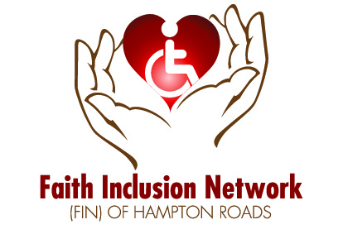

Discussion Guide

FIN That All May Worship-2015 Conference Videos

INTRODUCTION
These videos were produced from the That All May Worship-2015, Embracing Inclusion conference held in Virginia Beach, VA, in March, 2015. The study questions are designed to help groups come together around the question of how best to include people with disabilities in the life of their faith communities. Each video runs an average of five minutes, so that the group can watch the video, and process the questions at their leisure, to fit the available time frame.
The videos can be used with staff, with parents, with teens and older with disabilities, and for those interested in disability ministry. The questions are intended to help faith communities enter into the dialog that will lead to the “next steps,” those next steps being the action items that will lead to inclusion for all.
When you use these videos, we would appreciate your feedback. You can email Rosemarie Hughes, at rhughes87@cox.net or Karen Jackson at faithinclusionnetwork@gmail.com. We would like to know:
- How did you use these videos and questions?
- What was their value to you as a congregation?
- Suggestions you may have regarding either the videos or questions.
Thank you and we look forward to hearing from you. Also, you can contact us if you have questions or need resources. Our webpage is www.faithinclusionnetwork.org
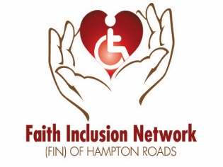
Presenter: Barbara Newman
Presentation Question: “What do welcoming congregations look like when we embrace inclusion?”
Suggested Audience: Faith Communities and Families, emphasis on youth inclusion
Discussion Questions:
- What were the two parts of Barb’s plan?
- How might Barb’s tools work in your own faith community?
- What other tools might be useful?
- Why is it important to include everyone in the faith community?
- How could you work with the worship leaders to implement an inclusive plan?
- What kind of information or preparation would you need before you create your plan?
Discussion Questions:
- What would you want your worship team to know about your child so that they could formulate a plan for inclusive worship?
- What other tools would be helpful to include your child in worship?

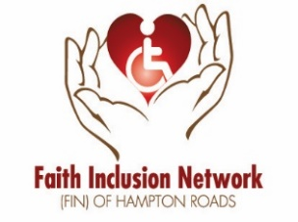
Presenter: Dan Vander Plaats
Presentation Question: “What do welcoming congregations look like when we embrace inclusion?”
Suggested Audience: Christian Faith Communities and Families
Discussion Questions:
- How does Dan use Ephesians 2:9 to show the necessity for inclusive ministry?
- How is disability inclusiveness a discipleship issue?
- What kind of assumptions do congregations make about individuals with a disability?
- According to Ephesians 2:9 God’s works are to be done by others. How can congregations offer opportunities for all people to do God’s works?
For Parents, youth and adults with disability
- What kinds of assumptions do people make about children and adults with disabilities?
- What would you like your faith community to know about the gifts of those with disabilities?
- What does Ephesians 2:9 say to you about the role of people with disabilities in your faith community.

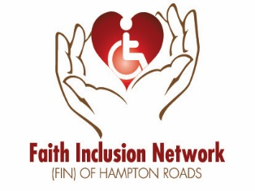
Presenter: David Morstad
Presentation Question: “What do welcoming congregations look like when we embrace inclusion?”
Suggested Audience: Faith Communities and Families-Interfaith
Discussion Questions:
- What does David mean by “I’ll know it when I don’t see it?”
- How is being inclusive a stewardship issues for a faith community?
- How can a faith community benefit in considering inclusiveness as a stewardship issue rather than a mercy issue?
- What would have to change in your faith community to full embrace an inclusive disability ministry?
- How would the concept of stewardship help promote those changes?
Presenter: Janice Benton
Presentation Question: “What person or persons have influenced you to embrace inclusion?”
Suggested Audience: Faith Communities
Discussion Questions:
- Has anyone in your faith community ever responded “Oh No” regarding a certain person as those in the nursing home responded to Marcella?
- How could your faith community embrace people with special needs, especially those who seem to be needing of more care?
- How did Marcella influence Janice?

- Janice stated that people with disabilities know their own needs; how can your faith community best learn about those needs?
- The example of using ceiling tile to say the Rosary demonstrated that access can be simple. Identify areas in your faith community that would be simple to change to create access?
- How can the quote from Howard Thurman be applicable to your faith community?

Presenter: Jeff McNair
Presentation Question: “What do welcoming congregations look like when we embrace inclusion?”
Suggested Audience: Christian Faith Communities
Discussion Questions:
- How do Colossians 2:10 and 1 Corinthians 12 show that a faith community in incomplete in the Body of Christ if it is not being inclusive to people with disabilities.
- Does adherence to traditions that are not Scriptural keep your faith community from embracing people with disabilities?
- What are social ramps and how can they effect change in your faith community?
- What are the resources in your faith community (or larger denomination) that could help create social ramps.
Presenter: Jolene Philo
Presentation Question: “What is inclusiveness important to you? What drives you?”
Suggested Audience: Christian Faith Communities and Families
Discussion Questions:
- How would Jolene’s father’s life have been different without the ministry of his faith community?
- How do you think Jolene’s support from her faith community when her child was young helped her family?
- How could Russell and people in similar circumstances have a different outlook on life with support of a faith community?
Presenter: Lorna Bradley
Presentation Question: What is an innovative program that can help faith communities embrace inclusion?
Suggested Audience: Parents of children with disabilities
Discussion Questions:
- How has having a child with a disability affected your family?
- What would a holistic family approach look like for helping a family affected by disability be included in a faith community?
- How can you, as a parent, convey those needs to your faith community?

Presenter: Milton Tyree
Presentation Question: Why is embracing inclusion important to you? What drives your passion?
Suggested Audience: Faith Communities and Families
Discussion Questions:
- Who in your faith community are “those people”?
- Are “those people” in the main stream of your community or are they marginalized?
- How might your congregation better welcome and accommodate for the unique needs of “those people”- people affected by disability-in your faith community?
- As human beings, we naturally categorize people we know. How might we move beyond this natural inclination and better recognize people in our congregation as individuals without categorizing them?
- How will you and your congregation respond to Milton’s challenge: “What are we going to do about it?”

Presenter: Mohammed Yousuf
Presentation Question: What person or experience has inspired you to embrace inclusion?
Suggested Audience: Faith Communities and Families
Discussion Questions:
- Mohammed’s story is one of hope. What does he attribute to his optimistic outlook?
- Can you identify a person that has been a “visionary” as Mohammed terms it, in your life? Could you be a “visionary” in the life of another person?
- Mohammed’s extremely positive attitude is infectious. How can your faith community encourage people with disabilities and create a positive environment for all?
Presenter: Shelly Christensen
Presentation Question: What is your best advice for faith communities beginning to embrace inclusion?
Suggested Audience: Faith Communities-Jewish, Interfaith
Discussion Questions:
- Who is missing from your congregation?
- What would your life be like if you were never a part of a faith community?
- Without making people with disabilities into “mitzvah projects”, how can you walk in their world and better understand their experience?

Presenter: Stephanie Hubach
Presentation Question: What does a welcoming congregation look like when we embrace inclusion?
Suggested Audience: Christian Faith Communities and Families
Discussion Questions:
- How is your church like a hospital and how it like a country club?
- How is love a motivation for an inclusion ministry?
- How is disability ministry more than a check list of accommodations?
- How can the concept of radical hospitality drive the goals for your disability ministry?
Presenter: Erik Carter
Presentation Question: Introduction to Embracing Inclusion
Suggested Audience: Faith Communities and Families, emphasis on introductory information about disability ministry.
Discussion Questions:
- Why does Erik believe the church is incomplete without persons with disabilities?
- What kind of data does Erik provide that show that faith communities still have a long way to go to be inclusive? Is your faith community indicative of these statistics?
- How is including people with disabilities essential and more than just nice?
- What does Erik mean by giving out “wild and wide invitations” to participate in corporate worship and activities of faith communities?
Presenter: Bill Gaventa
Presentation Topic: How can we move ahead to embrace inclusion?
Suggested Audience: Faith Communities and Families-Interfaith
Discussion Questions:
- According to Bill, what is beyond inclusion? What does belonging look like in your faith community?
- How do faith communities ensure that each person, as an image of God, is part of the community?
- How does Bill’s presentation encourage you to take action, make your own ripples and move forward in inclusion ministry?

