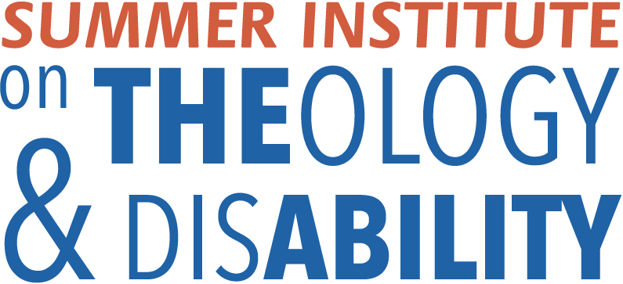
FACULTY
This group provides ongoing leadership, direction, and training for the Summer Institute. Not every faculty member is present at each Institute.

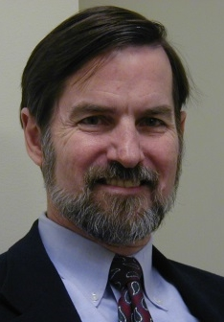
William C. Gaventa
The Rev. Bill Gaventa, Waco, Texas, is the director of the Summer Institute on Theology and Disability. He has been a frequent speaker, trainer, and workshop leader on the intersection between faith and disability. Gaventa is an associate editor of the Journal of Disability and Religion (formerly the Journal of Religion, Disability and Health) and edits the AAIDD e-newsletter, Gleanings. In 2013, he retired as director of Community and Congregational Supports and Associate Professor at the Elizabeth M. Boggs Center on Developmental Disabilities, UMDNJ-Robert Wood Johnson Medical School.

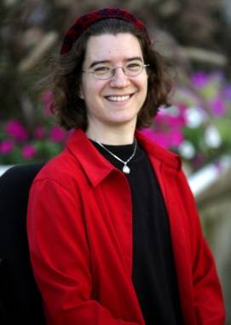
Julia Watts Belser
Rabbi Julia Watts Belser, Ph.D., is Assistant Professor of Jewish Studies in the Theology Department at Georgetown University. Her scholarship focuses on rabbinic Jewish culture in late antiquity, with particular expertise in disability, gender, and sexuality. Belser co-chairs the American Academy of Religion’s Program Unit in Religion and Disability Studies, and heads the AAR’s Committee on the Status of People with Disabilities in the Profession.
Belser is the co-author of A Health Handbook for Women with Disabilities (Hesperian Foundation, 2007). Her forthcoming book, Power, Ethics, and Ecology in Jewish Late Antiquity: Rabbinic Responses to Drought and Disaster, (Cambridge University Press) will publish in the fall of 2015.

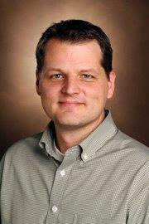
Erik Carter
Erik Carter holds a Ph.D. in special education from Vanderbilt University and a B.A. in Christian education from Wheaton College. As an associate professor of Special Education at Vanderbilt, Carter’s research and teaching focuses on strategies for supporting meaningful inclusion and promoting valued roles in school, work and community settings for children and adults with intellecutal and developmental disabilities. Among the books he’s authored is the influential People with Disabilities in Faith Communities: A Guide for Service Providers, Families, and Congregations (2007 Brookes Publishing).

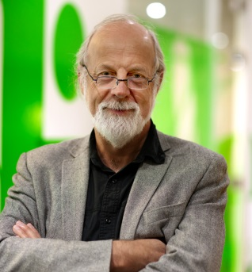
Hans S. Reinders
Hans S. Reinders, Ph.D., is professor of Ethics at VU University Amsterdam. He has published widely on disability issues in both secular and theological circles. Among his books are The Future of the Disabled in Liberal Society (Notre Dame Press, 2000), Receiving the Gift of Friendship (Eerdmans, 2008), and Disability, Providence, and Ethics: Bridging Gaps, Transforming Lives (Baylor Press, 2014). He serves as the editor of the Journal of Disability and Religion (formerly the Journal of Religion, Disability and Health.) Reinders is from the Reformed Church tradition.

Thomas E. Reynolds
Thomas E. Reynolds, Ph.D., is associate professor of Theology at Emmanuel College of Victoria University in the University of Toronto. Committed to an interdisciplinary and relational vision of theology, Reynolds’ teaching and research explore a range of topics related to Christian engagements with diversity in a global context. He authored The Broken Whole: Philosophical Steps Toward a Theology of Global Solidarity (SUNY Press, 2005); and Vulnerable Communion: A Theology of Disability and Hospitality (Brazos Press, 2008). He is member of a United Church of Canada congregation in Toronto.

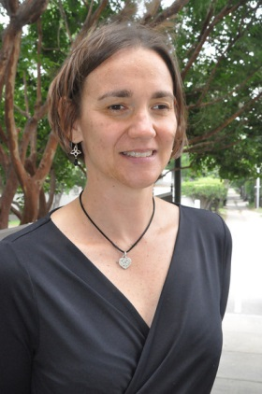
Darla Schumm
Darla Schumm, Ph.D., is professor of religious studies at Hollins University, a liberal arts women’s college nestled in the midst of the Blue Ridge Mountains. Schumm received her B.A. from Goshen College, Goshen, Ind. She has an M.A. in Social Ethics from the Pacific School of Religion in Berkeley, Calif., and a Ph.D. in Religion, Ethics, and Society from Vanderbilt University. Schumm’s current research focuses on intersections between religious studies and disability studies. She is the coeditor of three volumes on religion and disability, and the coeditor of a forthcoming textbook on world religions and disability. She is writing a book tentatively titled Religion and Disability in America. In her free time, Schumm enjoys traveling, running, knitting, reading fiction and playing with her son.

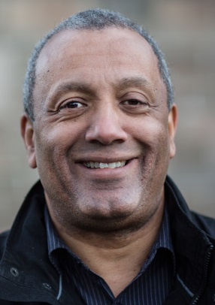
John Swinton
The Rev. John Swinton, Ph.D., holds the chair in Practical Theology and Pastoral Care at the University of Aberdeen, Scotland, United Kingdom. He worked for over a decade as a registered nurse in psychiatric and intellectual disability settings. His writings include Resurrecting the Person: Friendship and the Care of People with Mental Health Problems (Abington Press, 2000), and Critical Reflections on Stanley Hauerwas’ Essays on Disability: Disabling Society, Enabling Theology (Haworth Press, 2005). In 2004, he founded the Centre for Spirituality, Health and Disability at the University of Aberdeen. Swinton is an ordained minister of the Presbyterian Church of Scotland.

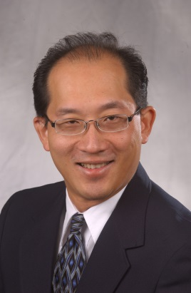
Amos Yong
Amos Yong, Ph.D., is the director of the Center for Missiological Research and Professor of Theology and Mission at Fuller Theological Seminary. He authored The Bible, Disability, and the Church (2011) and Theology and Down Syndrome: Reimaging Disability in Late Modernity (2007), among others. His graduate education includes degrees in theology, history, and religious studies from Western Evangelical Seminary (now George Fox Seminary) and Portland State University, Portland, Ore., and Boston University, Boston, Mass., and an undergraduate degree from Bethany University of the Assemblies of God. Yong and his wife, Alma Yong, reside in Chesapeake. They are members of New Life Providence Church in the Virginia Beach–Chesapeake area.

